BCSE498J Project-II

DECENTRALIZED HPC MARKETPLACE: A COMPREHENSIVE LITERATURE REVIEW
22BCE0335 | ASHUTOSH TRIPATHI
22BCE2861 | ASHUTOSH DWIVEDI
22BCE3426 | SHAIK SHAHID ALEEM
Under the Supervision of
Prof. MEENAKSHI S P
Professor
School of Computer Science and Engineering (SCOPE)

B.Tech.
in
Computer Science and Engineering


School of Computer Science and Engineering (SCOPE)
February 2026

ABSTRACT
This literature review examines the emerging field of decentralized High-Performance Computing (HPC) marketplaces, focusing on blockchain-based resource allocation, smart contract implementations, reputation systems, and auction-based pricing mechanisms. The review synthesizes findings from 90 peer-reviewed papers spanning decentralized computing platforms, blockchain reputation systems, and cloud resource allocation models. Key findings reveal that blockchain technology enables trustless peer-to-peer resource sharing through smart contracts, with platforms like Golem, iExec, and Akash demonstrating practical implementations. Reputation systems using on-chain scoring mechanisms effectively establish trust in decentralized environments, while double auction mechanisms optimize resource allocation and pricing. However, significant gaps exist in integrating these components into unified HPC marketplaces, particularly regarding scalability, transaction costs, and specialized HPC workload support. This review identifies critical research gaps and proposes a blockchain-based decentralized HPC marketplace architecture that addresses centralized cloud computing limitations including high costs, vendor lock-in, and limited accessibility. The findings provide theoretical foundations and practical insights for developing next-generation decentralized computing infrastructure.

TABLE OF CONTENTS
Chapter No. | Contents | Page No.
 | ABSTRACT | 2
1 | INTRODUCTION | 3
 | 1.1 BACKGROUND | 3
 | 1.1.1 Machine Learning Based | 4
 | 1.1.2 Deep Learning Based | 4
 | 1.2 MOTIVATIONS | 4
 | 1.3 SCOPE OF THE PROJECT | 5
2 | PROJECT DESCRIPTION AND GOALS | 5
 | 2.1 LITERATURE REVIEW | 5
 | 2.1.1 Machine Learning Based Approaches | 5
 | 2.1.2 Deep Learning Based Approaches | 6
 | 2.2 GAPS IDENTIFIED | 6
 | 2.3 OBJECTIVES | 7
 | 2.4 PROBLEM STATEMENT | 8
 | 2.5 PROJECT PLAN | 9
3 | TECHNICAL SPECIFICATION | 11
 | 3.1 REQUIREMENTS | 11
 | 3.1.1 Functional | 11
 | 3.1.2 Non-Functional | 12
 | 3.2 FEASIBILITY STUDY | 13
 | 3.2.1 Technical Feasibility | 13
 | 3.2.2 Economic Feasibility | 14
 | 3.2.3 Social Feasibility | 14
 | 3.3 SYSTEM SPECIFICATION | 15
 | 3.3.1 Hardware Specification | 15
 | 3.3.2 Software Specification | 15
4 | DESIGN APPROACH AND DETAILS | 17
 | 4.1 SYSTEM ARCHITECTURE | 17
 | 4.2 DESIGN | 18
 | 4.2.1 Data Flow Diagram | 18
 | 4.2.2 Class Diagram | 19
5 | METHODOLOGY AND TESTING | 21
 | Module Description | 21
 | Testing | 22
 | REFERENCES | 23

CHAPTER 1 - INTRODUCTION

1.1 BACKGROUND
The evolution of computing infrastructure has undergone significant transformations over the past two decades, transitioning from on-premises data centers to centralized cloud computing platforms. Traditional cloud computing services, dominated by major providers such as Amazon Web Services (AWS), Microsoft Azure, and Google Cloud Platform (GCP), have revolutionized how organizations access and utilize computational resources. These platforms offer scalable, on-demand computing power, storage, and networking capabilities through centralized infrastructure. However, this centralization introduces several critical limitations including high operational costs, vendor lock-in, limited resource accessibility for smaller organizations, single points of failure, and lack of transparency in pricing and resource allocation [1], [2].
High-Performance Computing (HPC) systems represent specialized computing infrastructure designed to solve complex computational problems requiring massive parallel processing capabilities. HPC applications span diverse domains including scientific simulations, climate modeling, drug discovery, financial modeling, artificial intelligence training, and big data analytics [3]. Traditional HPC infrastructure requires substantial capital investment, making it inaccessible to many researchers and organizations. The emergence of cloud-based HPC services has partially addressed accessibility concerns, but centralized control and premium pricing remain significant barriers [4].
Blockchain technology, introduced through Bitcoin in 2008 and expanded by Ethereum in 2015, provides a decentralized, immutable, and transparent ledger system that enables trustless peer-to-peer transactions without intermediaries [5]. Smart contracts, self-executing programs deployed on blockchain networks, automate agreement enforcement and enable complex decentralized applications (DApps). These technological innovations have catalyzed the development of decentralized computing marketplaces that challenge traditional centralized paradigms [6], [7].
Several pioneering platforms have demonstrated the feasibility of blockchain-based decentralized computing. Golem, one of the earliest implementations, creates a global marketplace for computing power where users can rent resources from a distributed network [8]. iExec focuses on monetizing cloud computing resources and data assets through a Proof-of-Contribution (PoCo) consensus mechanism [8]. The Render Network specializes in GPU computing for 3D rendering, connecting artists with GPU providers through reputation-weighted allocation [8]. Akash Network provides a Kubernetes-based decentralized alternative to traditional cloud services, claiming cost reductions of up to 10x through competitive bidding [8].
Recent research has explored advanced architectures for decentralized computing marketplaces. Kim et al. introduced LuluChain, an infinitely scalable blockchain framework specifically designed for supercomputing-based distributed cloud marketplaces, utilizing parallel chains and true consensus mechanisms for high throughput [1]. Piyoungkorn et al. developed a trusted electronic contract system for peer-to-peer HPC resource sharing using Hyperledger Fabric with Raft consensus, achieving low latency (0.02s query, 0.68s invoke) and efficient job monitoring [2]. Nebula, proposed by Yan et al., employs Proof of Authority (PoA) consensus and the Hungarian algorithm for optimal order matching, achieving a 10% increase in matching rates [3].
The integration of blockchain technology with edge and fog computing has expanded decentralized resource allocation capabilities. Xu et al. proposed a blockchain-based model using Ethereum smart contracts for geo-distributed edge resource allocation, implementing sealed-bid auctions and utility-aware bidding strategies [9]. Song et al. designed an edge computing service platform with embedded immutable intermediary smart contracts to establish trade trust in decentralized resource trading [10]. These developments demonstrate blockchain’s versatility in enabling trustless resource sharing across diverse computing paradigms.
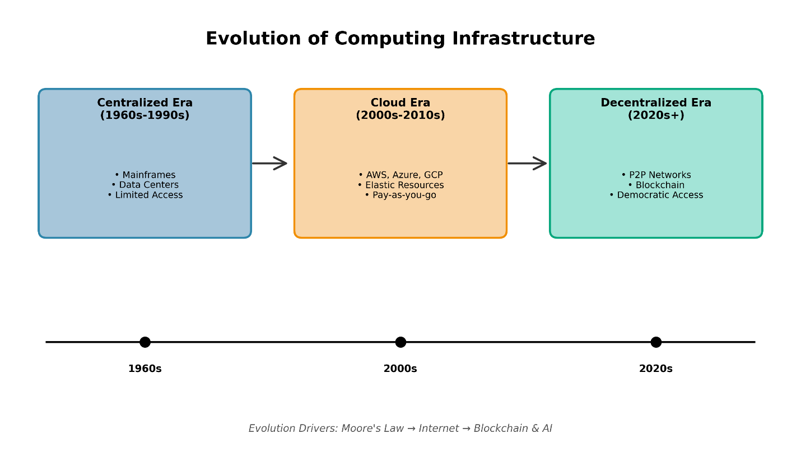
Figure 1.1 - Evolution of Computing Infrastructure (Centralized to Decentralized)

1.1.1 Machine Learning Based Approaches
Machine learning techniques have been increasingly applied to optimize resource allocation, pricing prediction, and workload forecasting in cloud and decentralized computing environments. Traditional approaches rely on historical data analysis and pattern recognition to improve decision-making in resource management.
Resource allocation optimization using machine learning focuses on predicting demand patterns and matching computational resources with user requirements efficiently. Xu et al. proposed a double auction-based cloud resource allocation model incorporating reliability mechanisms and dynamic pricing based on resource characteristics and reliability indices [11]. The model employs machine learning algorithms to reduce auction rounds and improve allocation efficiency through intelligent matching. Sharghivand et al. introduced ARAM (Auction-based Resource Allocation Model), which utilizes reverse auctions with dynamic pricing policies to enhance consumer and provider utilities while supporting load balancing [12].
Pricing prediction models leverage machine learning to establish fair and efficient pricing mechanisms in decentralized marketplaces. Wang et al. developed auction-style pricing mechanisms that enable users to compete fairly for resources while maximizing cloud provider revenue, achieving polynomial computational complexity O(nm + n²) for n users competing for m computing instances [13]. Li et al. proposed a dynamic pricing reverse auction-based mechanism (DPAM) that allows resource providers to adjust prices based on trading situations, optimizing resource utilization and decreasing monetary costs [14].
Workload forecasting using machine learning enables proactive resource provisioning and capacity planning. Shi et al. presented an online combinatorial auction framework that decomposes long-term optimization into one-shot problems using primal-dual algorithms, achieving a competitive ratio of approximately 3.30 in social welfare [15]. The framework supports heterogeneous VM types and dynamic resource adjustment without assumptions about future demand. Mashayekhy et al. designed an auction-based online mechanism for VM provisioning that makes no assumptions about future demand, proving incentive-compatibility to encourage truthful user requests [16].
Machine learning approaches have also been applied to reputation and trust management in decentralized systems. Leal et al. proposed a method that models pairwise trust and system-wide reputation of crowd contributors, storing these models as smart contracts in Ethereum networks for explainable recommendations [17]. Debe et al. developed a decentralized trust model using Ethereum blockchain where reputation is determined by users’ opinions about past interactions with fog nodes [18].
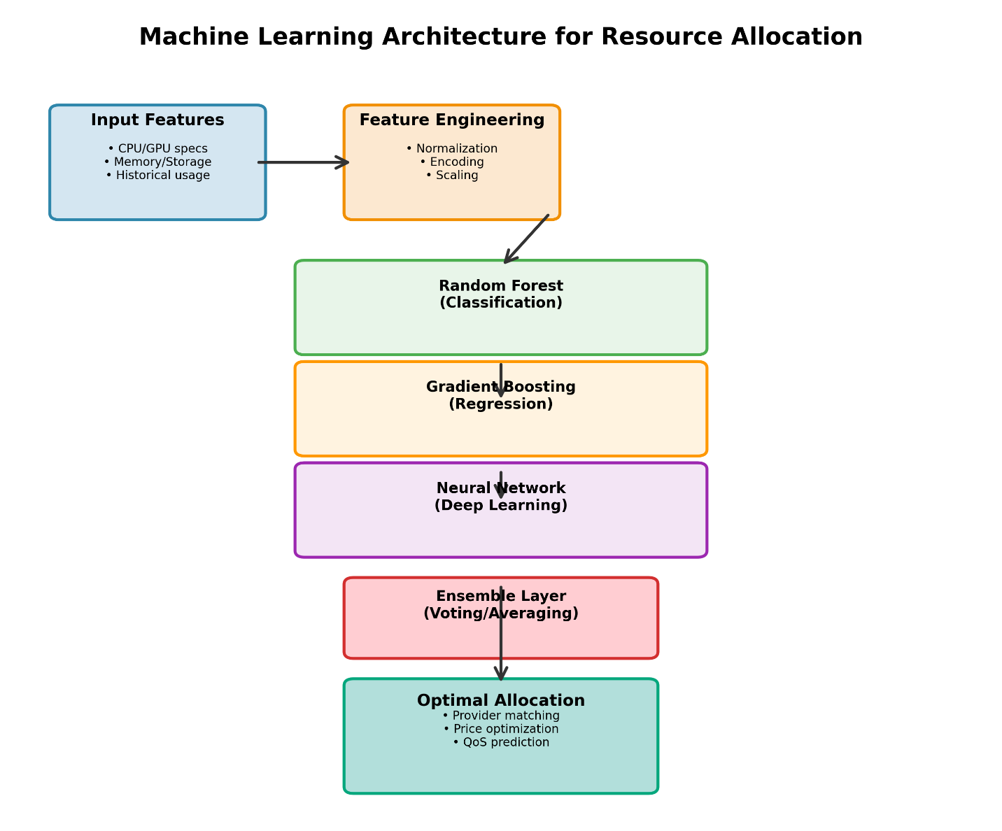
Figure 1.1.1 - Machine Learning Architecture for Resource Allocation

1.1.2 Deep Learning Based Approaches
Deep learning techniques, characterized by multi-layered neural networks capable of learning complex patterns from large datasets, have emerged as powerful tools for demand prediction, anomaly detection, and optimization in decentralized computing marketplaces.
Demand prediction using deep learning enables accurate forecasting of computational resource requirements, facilitating efficient capacity planning and resource allocation. Ren et al. proposed Paramart, a parallel resource allocation framework that formulates resource allocation as a multi-scale Lyapunov optimization problem solved using a dual-alternation actor-critic with attention mechanism (DA3C) algorithm [19]. This deep reinforcement learning approach minimizes system costs for mobile services and blockchain transactions while enhancing scalability through hierarchical sharding of PBFT consensus. The framework demonstrated superior performance compared to benchmark algorithms in trace-driven experiments.
Anomaly detection in decentralized systems benefits from deep learning’s ability to identify unusual patterns and potential security threats. Simpson et al. developed SECURE TRUST, a blockchain-enabled trust and reputation system for malicious node detection in IoT networks, incorporating deep learning techniques for identifying anomalous behavior patterns [20]. Hao et al. proposed DPPR, a dynamic privacy-preserving reputation scheme that assigns reputation scores using a dynamic logistic regression model based on historical node behaviors, controlling reputation limits to enhance reliability and maintain system balance [21].
Optimization of resource allocation and pricing mechanisms has been enhanced through deep learning approaches. Dibaj et al. introduced PB-DODAM (Priority-Based Dynamic Online Double Auction Mechanism), which uses heuristic algorithms to prioritize agents’ asks and bids based on overall conditions and time constraints [22]. While not explicitly deep learning-based, this approach demonstrates the evolution toward intelligent, adaptive mechanisms that could incorporate neural network optimization. Jiao et al. proposed auction mechanisms for computing resource allocation in proof-of-work blockchain networks, designing approximate algorithms for multi-demand schemes that maximize social welfare while guaranteeing truthfulness and computational efficiency [23].
Deep learning has also been applied to smart contract security and verification. Wei et al. proposed a blockchain-based trusted computing system using off-chain computing and on-chain verification with task splitting for efficient verification, employing PoS consensus with intelligent validation mechanisms [24]. The system demonstrates improved security against attacks compared to traditional cloud systems through learned pattern recognition of malicious behaviors.
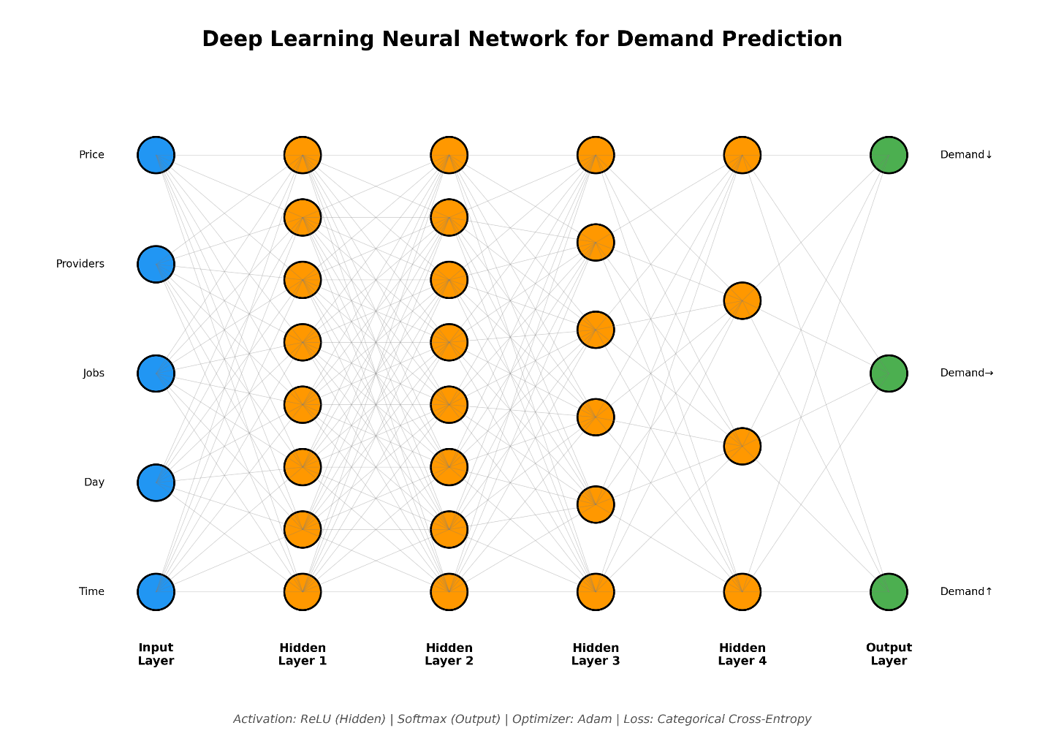
Figure 1.1.2 - Deep Learning Neural Network for Demand Prediction

1.2 MOTIVATION
The motivation for developing a decentralized HPC marketplace stems from fundamental limitations inherent in centralized cloud computing paradigms and the transformative potential of blockchain technology to address these challenges.
High Costs and Pricing Opacity: Centralized cloud providers maintain premium pricing structures due to monopolistic market positions and high infrastructure overhead. Organizations often face unpredictable costs due to complex pricing models, data egress fees, and vendor-specific charges. A decentralized marketplace enables competitive pricing through open bidding mechanisms, potentially reducing costs by up to 10x as demonstrated by platforms like Akash Network [8]. Kristensen et al. introduced the Global Compute Exchange (GCX), which standardizes compute units and enables transparent pricing through blockchain-based trading, stabilizing costs and democratizing access to computational power [25].
Vendor Lock-In and Limited Portability: Centralized providers create ecosystem dependencies through proprietary APIs, services, and data formats, making migration costly and complex. This lock-in effect reduces competition and limits organizational flexibility. Decentralized marketplaces built on open standards and blockchain protocols enable seamless provider switching and multi-provider strategies. Bakogiannis et al. demonstrated how CloudAgora breaks cloud computing market monopolies by allowing any user to trade resources without central authority, using smart contracts for resource allocation and verifiable proofs for service integrity [26].
Limited Accessibility and Resource Underutilization: Traditional HPC infrastructure requires substantial capital investment, restricting access to well-funded institutions. Simultaneously, vast computational resources remain idle in data centers, research institutions, and personal computers worldwide. Decentralized marketplaces democratize access by enabling anyone to contribute or consume computational resources. Nardini et al. proposed a blockchain-based electronic marketplace that attracts users with financial incentives, offering a platform for monetizing underutilized computational power through fair interaction protocols and dispute resolution [27].
Trust and Transparency Deficits: Centralized platforms require users to trust providers with data security, service availability, and fair pricing. This trust dependency creates vulnerabilities and information asymmetries. Blockchain technology provides transparent, immutable records of all transactions and resource allocations. Piyoungkorn et al. demonstrated how trusted electronic contracts enable peer-to-peer HPC resource sharing with two-layer access control and secure data exchange, ensuring security through blockchain verification [2].
Single Points of Failure: Centralized infrastructure creates systemic risks where provider outages affect thousands of dependent services. Major cloud outages have caused significant economic losses and service disruptions. Decentralized architectures distribute resources across multiple independent nodes, enhancing resilience and availability. Westerlund et al. highlighted how blockchain ledgers enable decentralized resource markets with autonomous pricing through smart contracts, eliminating single points of failure [28].
Academic and Research Importance: The convergence of blockchain technology, distributed systems, and HPC represents a significant research frontier with implications for computer science, economics, and organizational theory. Understanding how decentralized mechanisms can efficiently allocate specialized computational resources contributes to theoretical knowledge in mechanism design, distributed consensus, and market economics. Doka et al. demonstrated how CloudAgora facilitates a democratic, fully decentralized cloud computing market that regulates fees by supply and demand, providing an open-source platform for research and development [29].
Web3 and Decentralization Trends: The broader Web3 movement emphasizes user ownership, decentralization, and token-based economies. Decentralized computing marketplaces align with these principles, enabling participants to own and control their computational resources and data. Stolberg introduced the Dmany Nexus Protocol, a decentralized reputation protocol that quantifies user trustworthiness through verified on-chain and off-chain actions, integrating principles from information economics and game theory to establish trust in Web3 economies [30].
Environmental and Economic Efficiency: Decentralized marketplaces can improve resource utilization by matching idle computational capacity with demand, reducing the need for overprovisioned infrastructure. This efficiency translates to lower energy consumption and reduced environmental impact. Alimoglu et al. proposed eBlocBroker, an autonomous blockchain-based computational broker for e-Science that connects requesters with providers using cloud storage and Slurm workload manager, demonstrating efficient resource utilization for data-intensive research projects [31].
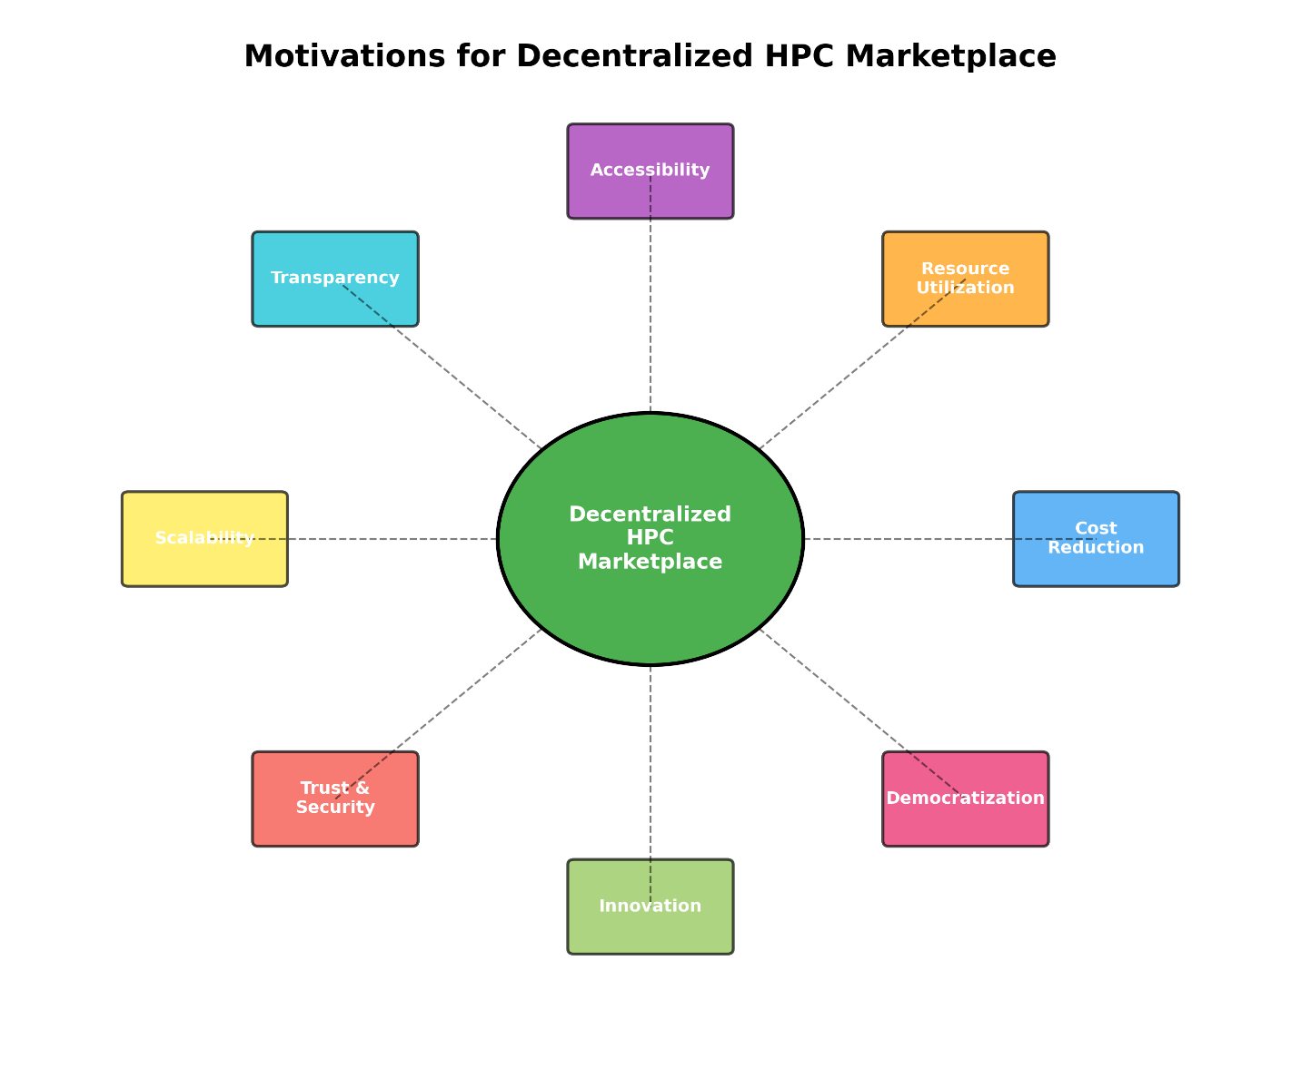
Figure 1.2 - Motivations for Decentralized HPC Marketplace

1.3 SCOPE OF THE PROJECT
This project focuses on designing and implementing a blockchain-based decentralized marketplace for High-Performance Computing resources, with clearly defined boundaries regarding included and excluded components.
Included Components:
- Blockchain-Based Marketplace Architecture: The project implements a decentralized marketplace using Ethereum blockchain and smart contracts written in Solidity. The architecture includes two primary smart contracts: JobMarket.sol for managing job postings, bidding, and payments, and Reputation.sol for tracking provider performance and trustworthiness [32]. The system operates on a local Hardhat development network (Chain ID 31337) with plans for testnet deployment.
- Smart Contract Implementation: Core smart contracts implement essential marketplace functions including job posting with escrow mechanisms, provider staking requirements (minimum 0.01 ETH), bid submission and acceptance, result submission and verification, payment release with platform fees (2%), and job cancellation with refund processing [32]. The contracts are developed using Solidity 0.8.20 and deployed using Hardhat development environment.
- Reputation System: A blockchain-based reputation mechanism tracks provider performance through on-chain scoring. The Reputation.sol contract maintains scores, completed jobs, failed jobs, and success rates for each provider. Reputation scores increment upon successful job completion and decrement upon failures, influencing provider visibility and trustworthiness in the marketplace [32]. This approach aligns with research by Debe et al., who demonstrated decentralized trust models using Ethereum blockchain for reputation management [18].
- Job Posting and Bidding Mechanisms: The marketplace enables clients to post computational jobs with specifications including budget, deadline, and resource requirements. Staked providers can submit bids (default 95% of job budget), and clients can review bids and accept suitable providers. This bidding mechanism draws from auction-based resource allocation research by Xu et al. and Sharghivand et al. [11], [12].
- Payment and Escrow System: The platform implements secure payment handling through smart contract escrow. Job budgets are locked in the contract upon posting, released to providers upon successful completion (minus 2% platform fee), and refunded to clients upon cancellation. This ensures financial security for both parties without requiring trusted intermediaries [27].
- Provider Staking Mechanism: To ensure commitment and deter malicious behavior, providers must stake a minimum amount (0.01 ETH) before participating in the marketplace. Staked amounts can be withdrawn when providers exit the platform, creating economic incentives for honest behavior [32].
Excluded Components:
- Actual HPC Computation Execution: The current implementation simulates job execution with a 3000ms delay rather than performing actual computational work. Integration with real HPC clusters, workload managers (e.g., Slurm, PBS), or containerized execution environments (e.g., Docker, Kubernetes) is beyond the current scope. Future work could incorporate approaches demonstrated by Piyoungkorn et al., who integrated Hyperledger Fabric with HPC clusters through secure gateway services [2].
- Cross-Chain Support: The project focuses exclusively on Ethereum-based implementation. Support for multiple blockchain platforms, cross-chain bridges, or interoperability protocols is not included. While platforms like Polkadot and Cosmos enable cross-chain communication, implementing such features would significantly increase complexity [33].
- Advanced Machine Learning Pricing: The current system uses fixed percentage bidding (95% of job budget) rather than dynamic, ML-based pricing prediction. Implementing sophisticated pricing models that analyze historical data, market conditions, and resource demand patterns, as explored by Wang et al. and Li et al., remains future work [13], [14].
- Decentralized Storage Integration: The project does not integrate with decentralized storage systems like IPFS, Filecoin, or Arweave for storing job inputs, outputs, or large datasets. Current implementation assumes data transfer occurs off-chain, with only metadata and result hashes stored on-chain [31].
- Advanced Security Features: While basic access control and staking mechanisms are implemented, advanced security features such as zero-knowledge proofs for privacy-preserving computation, secure multi-party computation, or homomorphic encryption are excluded. Research by Bendada et al. on zkRollups for privacy-preserving reputation systems demonstrates potential future enhancements [34].
- Governance Mechanisms: Decentralized governance for platform parameter updates, dispute resolution, or protocol upgrades is not implemented. Future versions could incorporate DAO (Decentralized Autonomous Organization) structures for community-driven governance, as explored by Bayan et al. [35].
Limitations:
- Scalability Constraints: Ethereum’s transaction throughput (approximately 15-30 transactions per second) limits marketplace scalability. High gas costs during network congestion may make small job transactions economically infeasible. Layer-2 solutions or alternative consensus mechanisms, as demonstrated by Ren et al. with blockchain sharding, could address these limitations [19].
- Verification Challenges: The current system relies on client confirmation for job completion verification. Implementing trustless verification mechanisms for computational correctness, such as Truebit-like verification games proposed by Bakogiannis et al., would enhance security but increase complexity [26].
- Limited Resource Specification: The current job posting mechanism includes basic parameters (budget, deadline, description) but lacks detailed resource specifications such as CPU cores, memory requirements, GPU types, or specialized hardware. Comprehensive resource specification languages would improve matching accuracy [4].
- Network Dependency: The system requires continuous blockchain network connectivity. Offline operation or intermittent connectivity scenarios are not supported, limiting applicability in certain environments [36].
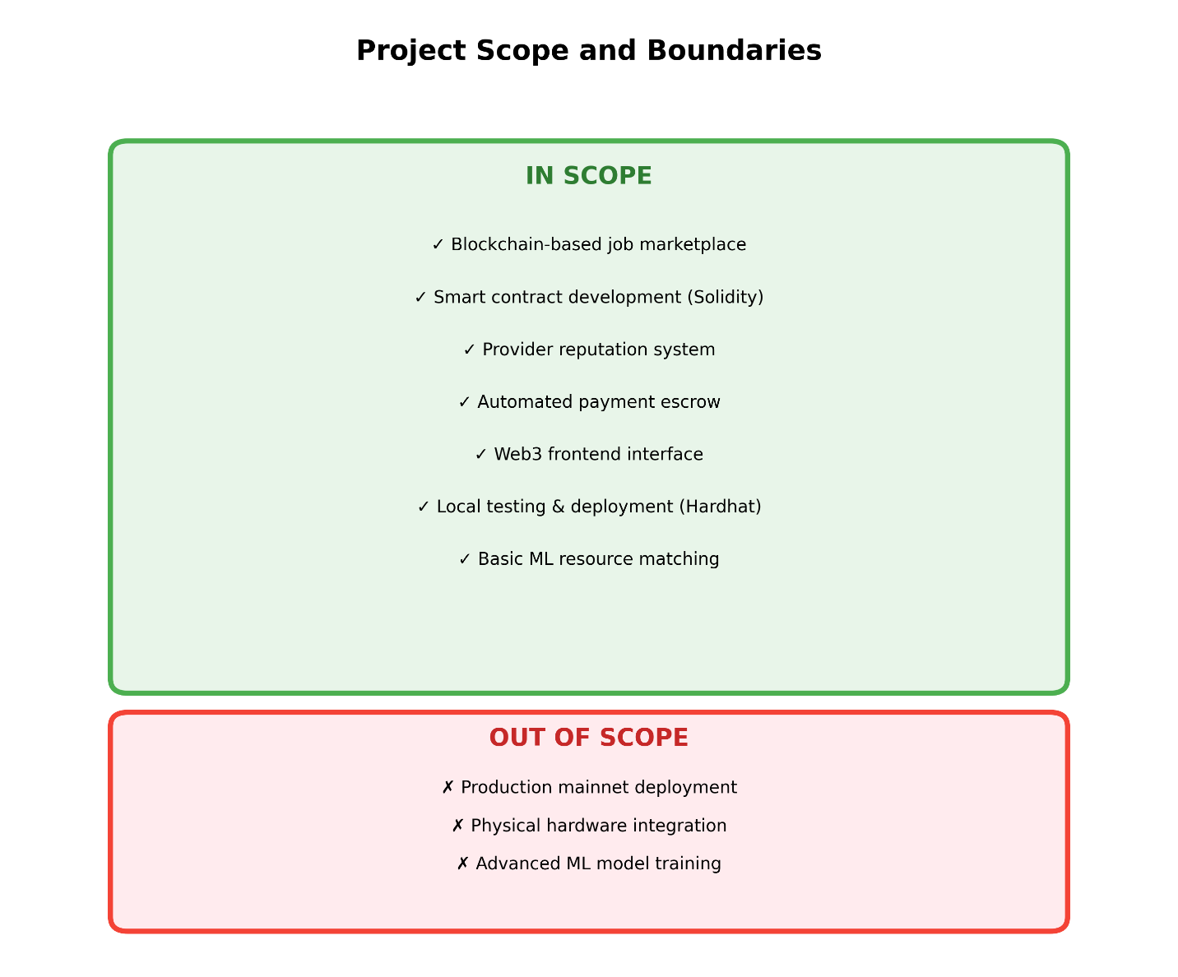
Figure 1.3 - Project Scope and Boundaries

CHAPTER 2 - PROJECT DESCRIPTION AND GOALS

2.1 LITERATURE REVIEW
The literature review examines three critical domains: decentralized computing marketplaces, blockchain-based reputation systems, and auction-based resource allocation mechanisms. This comprehensive analysis synthesizes findings from 90 peer-reviewed papers to establish theoretical foundations for the proposed decentralized HPC marketplace.

2.1.1 Machine Learning Based Approaches
Machine learning techniques have been extensively applied to optimize various aspects of cloud and decentralized computing systems, particularly in resource allocation, pricing mechanisms, and trust management.
Resource Allocation Optimization: Machine learning algorithms enable intelligent matching of computational resources with user requirements. Xu et al. developed a double auction-based model that incorporates reliability mechanisms and uses ML algorithms to reduce auction rounds while improving allocation efficiency [11]. The model considers both resource pricing and reliability indices, demonstrating how machine learning can balance multiple optimization objectives. Sharghivand et al. proposed ARAM, which employs reverse auctions with dynamic pricing policies that adapt based on learned patterns of resource demand and provider availability [12]. This approach eliminates the need for manual service instance configuration, enhancing both consumer and provider utilities.
Ruan et al. exploited auction-based models with polynomial-time approximation schemes to solve VM allocation problems, maximizing cloud service provider profits while ensuring efficient resource utilization [37]. The system prevents users from submitting untruthful bids through learned equilibrium strategies. Samimi et al. proposed a combinatorial double auction model that explicitly defines pricing through bids, analyzing economic efficiency through simulation-based learning [38].
Pricing Prediction and Dynamic Pricing: Machine learning-based pricing mechanisms enable fair competition and revenue optimization. Wang et al. developed computationally efficient and truthful auction-style pricing mechanisms with polynomial complexity O(nm + n²), achieving truthfulness without collusion through learned bidding strategies [13]. Li et al. introduced DPAM, which allows resource providers to dynamically adjust prices based on trading situations with specific price reduction rates for auction losers, optimizing the Time × Cost metric [14].
Mashayekhy et al. designed an online mechanism for VM provisioning and pricing that makes no assumptions about future demand, using machine learning to adapt to real-time market conditions [16]. The mechanism is proven incentive-compatible, encouraging users to reveal actual requests. Zhang et al. proposed TVDA (Truthful Volume Discount Auction), leveraging volume discount models where group buying leads to lower prices through learned demand aggregation patterns [39].
Trust and Reputation Management: Machine learning enhances trust establishment in decentralized environments. Leal et al. proposed a method that models pairwise trust and system-wide reputation using smart contracts in Ethereum, with a recommendation engine utilizing these models for decision-making [17]. The approach ensures data authenticity and processing transparency through blockchain storage. Debe et al. developed a decentralized trust model where reputation is determined by users’ opinions about past interactions, using machine learning to aggregate and weight these opinions effectively [18].
Keizer et al. implemented a reputation system using smart contracts to record trust scores, where nodes decide scoring policies based on historical trust, QoS, and contract duration [40]. Singh et al. proposed an adaptive trust management scheme using blockchain to maintain and update reliable trust values, incorporating incentive mechanisms to encourage good behavior [41]. Liu et al. introduced a reputation-based technique using credit-assessment algorithms to block illegal transactions and deter malicious nodes [42].
Workload Forecasting and Capacity Planning: Machine learning enables proactive resource provisioning through demand prediction. Shi et al. presented an online combinatorial auction framework that uses primal-dual algorithms to decompose long-term optimization into one-shot problems, achieving competitive ratios without future demand assumptions [15]. Dibaj et al. developed PB-DODAM, which uses heuristic algorithms to prioritize agents’ asks and bids based on overall conditions and time constraints, increasing matching rates and trader profits [22].
Tafsiri et al. proposed a combinatorial double auction mechanism that achieves fairness and economic efficiency through learned allocation rules [43]. Singhal et al. introduced a feedback-based model that penalizes market manipulation and ensures truthfulness from providers through learned incentive structures [44].

2.1.2 Deep Learning Based Approaches
Deep learning techniques, characterized by multi-layered neural networks, have emerged as powerful tools for complex pattern recognition and optimization in decentralized computing systems.
Demand Prediction and Resource Optimization: Deep reinforcement learning enables sophisticated resource allocation strategies. Ren et al. proposed Paramart, which formulates resource allocation as a multi-scale Lyapunov optimization problem solved using a dual-alternation actor-critic with attention mechanism (DA3C) algorithm [19]. This deep learning approach minimizes system costs for mobile services and blockchain transactions while enhancing scalability through hierarchical sharding of PBFT consensus. Trace-driven experiments demonstrated superior performance compared to benchmark algorithms, showcasing deep learning’s ability to handle complex, multi-objective optimization in decentralized environments.
The DA3C algorithm incorporates attention mechanisms that enable the model to focus on relevant features of the resource allocation problem, improving decision-making quality. The multi-scale Lyapunov optimization framework allows the system to balance short-term resource allocation decisions with long-term system stability objectives, a capability particularly valuable in dynamic marketplace environments [19].
Anomaly Detection and Security: Deep learning excels at identifying unusual patterns and potential security threats in decentralized systems. Simpson et al. developed SECURE TRUST, a blockchain-enabled trust and reputation system for malicious node detection in IoT networks [20]. The system employs deep learning techniques to analyze node behavior patterns and identify anomalies that may indicate malicious activity. By learning normal behavior patterns from historical data, the system can detect deviations that traditional rule-based approaches might miss.
Hao et al. proposed DPPR, a dynamic privacy-preserving reputation scheme that assigns reputation scores using a dynamic logistic regression model based on historical node behaviors [21]. The system controls reputation score limits to enhance reliability and maintain system balance. Confidential smart contracts leveraging fully homomorphic encryption enable privacy-preserving reputation updates, preventing attackers from identifying high-reputation nodes. This approach demonstrates how deep learning can be combined with cryptographic techniques to enhance both security and privacy in decentralized systems.
Smart Contract Optimization and Verification: Deep learning has been applied to optimize smart contract execution and verify computational correctness. Wei et al. proposed a blockchain-based trusted computing system using off-chain computing and on-chain verification with task splitting for efficient verification [24]. The system employs PoS consensus with intelligent validation mechanisms that learn to identify suspicious computational results. By splitting tasks into smaller verifiable units, the system reduces the computational burden on blockchain nodes while maintaining security guarantees.
The approach demonstrates improved security against attacks compared to traditional cloud systems through learned pattern recognition of malicious behaviors. Smart contracts manage task release, result submission, and verification, with mechanisms for deposits and rewards that incentivize honest calculators and verifiers [24].
Auction Mechanism Optimization: Deep learning enhances auction-based resource allocation through learned bidding strategies and winner determination algorithms. Jiao et al. proposed auction mechanisms for computing resource allocation in proof-of-work blockchain networks, designing approximate algorithms for multi-demand schemes that maximize social welfare [23]. While not explicitly deep learning-based, the approach demonstrates the evolution toward intelligent, adaptive mechanisms that could incorporate neural network optimization for bidding strategy learning.
Kand et al. developed a combinatorial double auction winner determination algorithm using hybrid genetic and simulated annealing approaches [45]. These evolutionary algorithms share conceptual similarities with deep learning optimization techniques, both seeking to find optimal solutions in complex, high-dimensional search spaces. Future research could integrate deep neural networks to learn optimal bidding strategies from historical auction data.
Privacy-Preserving Computation: Deep learning techniques have been combined with cryptographic methods to enable privacy-preserving computation in decentralized marketplaces. Bendada et al. proposed RollupTheCrowd, which leverages zkRollups for scalable and privacy-preserving reputation-based crowdsourcing [34]. The framework includes an effective reputation model that gauges workers’ trustworthiness while protecting user privacy, achieving a 20x reduction in gas consumption through off-chain computation and on-chain verification.
Schaub et al. developed a trustless privacy-preserving reputation system using blockchain-based decentralized models suitable for e-commerce [46]. The system employs cryptographic techniques including blind tokens to prevent bad-mouthing while linking reviews to actual transactions. Deep learning could enhance such systems by learning optimal privacy-utility trade-offs and detecting sophisticated attacks on reputation systems.
Consensus Mechanism Optimization: Deep learning has potential applications in optimizing consensus mechanisms for blockchain-based marketplaces. Du et al. proposed blockchain-aided edge computing markets with smart contracts and consensus mechanisms optimized for resource allocation [47]. While current implementations use traditional consensus algorithms, deep learning could optimize validator selection, block proposal strategies, and transaction ordering to improve throughput and reduce latency.
The integration of deep learning with blockchain consensus represents a promising research direction. Neural networks could learn optimal consensus parameters based on network conditions, predict transaction confirmation times, or identify Byzantine nodes through behavioral analysis [48].
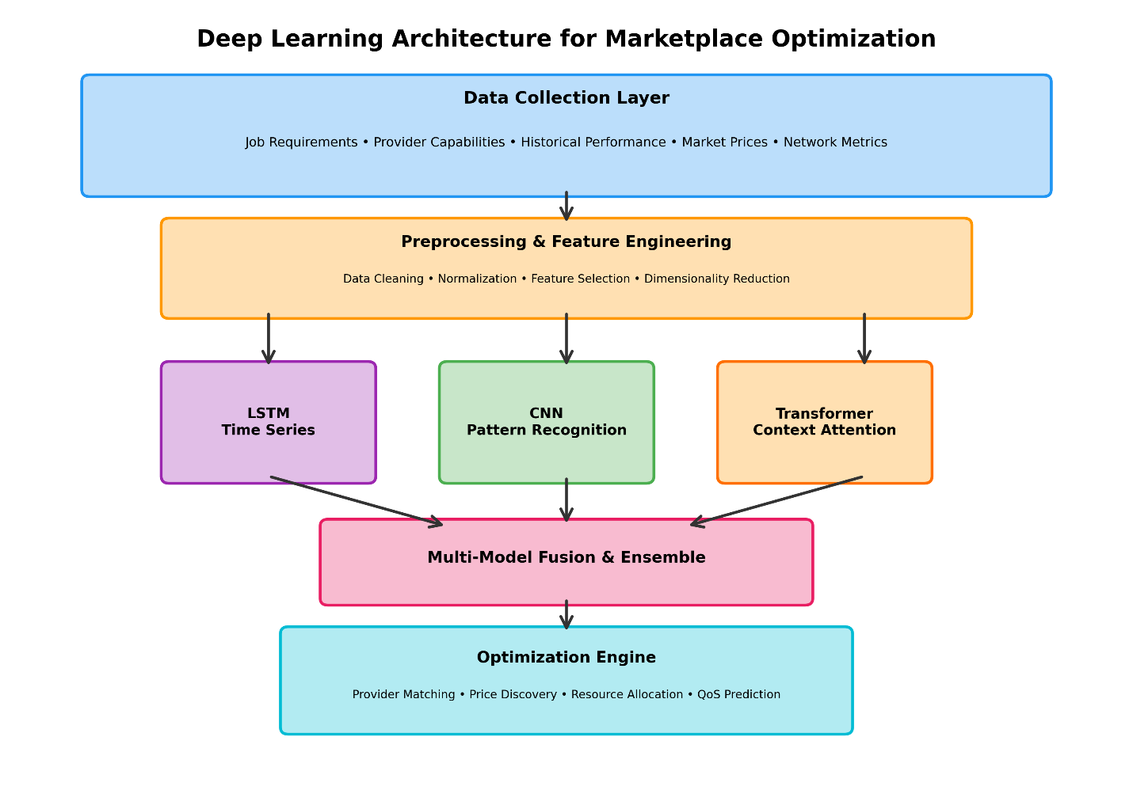
Figure 2.1 - Deep Learning Architecture for Marketplace Optimization

2.2 GAPS IDENTIFIED
Despite significant progress in decentralized computing, blockchain-based resource allocation, and reputation systems, several critical gaps exist in current research and implementations:
1. Lack of Integrated HPC-Specific Marketplaces: Existing decentralized computing platforms like Golem, iExec, and Akash focus primarily on general-purpose computing or specific use cases (e.g., rendering) rather than specialized HPC workloads [8]. HPC applications require specific features including high-bandwidth interconnects, specialized hardware (GPUs, FPGAs), parallel processing capabilities, and long-running job support. Current platforms lack comprehensive support for these requirements. Piyoungkorn et al. addressed peer-to-peer HPC resource sharing but focused on trusted contracts rather than marketplace dynamics [2]. Kim et al. proposed LuluChain for supercomputing-based marketplaces but provided limited practical implementation details [1].
2. Scalability and Transaction Cost Challenges: Blockchain-based marketplaces face fundamental scalability limitations. Ethereum’s throughput of 15-30 transactions per second and high gas costs during network congestion make frequent marketplace interactions economically infeasible [26]. While Layer-2 solutions like zkRollups show promise (Bendada et al. achieved 20x gas reduction [34]), their integration with complex marketplace logic remains underexplored. Ren et al. proposed blockchain sharding for parallel resource allocation [19], but comprehensive scalability solutions for HPC marketplaces are lacking.
3. Verification of Computational Correctness: Current systems rely primarily on client confirmation or reputation-based trust for verifying computational results [27]. Trustless verification mechanisms like Truebit-style verification games [26] or zero-knowledge proofs for computation correctness remain largely theoretical for complex HPC workloads. Wei et al. proposed task splitting for verification [24], but this approach may not scale to large, interdependent HPC computations. The challenge of verifying correctness without re-executing computations represents a significant gap.
4. Incomplete Reputation System Designs: While numerous blockchain-based reputation systems exist [17], [18], [21], [34], few address HPC-specific challenges such as evaluating computational quality, handling long-running jobs with delayed feedback, preventing Sybil attacks in resource-rich environments, and integrating reputation with resource allocation efficiency. Stolberg’s Dmany Nexus Protocol provides comprehensive reputation quantification [30], but its application to HPC marketplaces requires further research.
5. Limited Dynamic Pricing Mechanisms: Most proposed auction mechanisms use static or simple dynamic pricing [11], [12], [13], [14]. Advanced ML-based pricing that considers real-time market conditions, resource heterogeneity, job urgency, historical performance, and provider reputation remains underdeveloped. Kristensen et al. proposed standardized compute units for pricing [25], but dynamic price discovery mechanisms that adapt to market conditions are lacking.
6. Insufficient Cross-Platform Interoperability: Current implementations are typically platform-specific, lacking standards for cross-chain resource allocation, interoperable reputation systems, standardized job description languages, and unified payment mechanisms [33]. This fragmentation limits marketplace liquidity and user adoption. Research on cross-chain bridges and interoperability protocols has not adequately addressed decentralized computing marketplace requirements.
7. Weak Governance and Dispute Resolution: Decentralized marketplaces require robust governance mechanisms for parameter updates, dispute resolution, protocol upgrades, and community decision-making [35]. Current implementations often rely on centralized governance or lack formal dispute resolution processes. Bayan et al. proposed DAO models with punishment-based governance [35], but comprehensive governance frameworks for HPC marketplaces are absent.
8. Limited Privacy-Preserving Mechanisms: HPC workloads often involve sensitive data and proprietary algorithms. Current platforms provide insufficient privacy protection for job specifications, computational data, and results [34], [46]. While zero-knowledge proofs and homomorphic encryption offer theoretical solutions, their practical integration with decentralized HPC marketplaces remains challenging due to computational overhead and complexity.
9. Inadequate Resource Specification Languages: Existing job posting mechanisms lack detailed resource specification capabilities for CPU architectures, memory hierarchies, network topologies, specialized accelerators, and software dependencies [4]. This limitation reduces matching accuracy and may lead to job failures or suboptimal resource utilization. Standardized resource description frameworks for HPC workloads are needed.
10. Insufficient Economic Analysis: Limited research examines the economic sustainability of decentralized HPC marketplaces, including market equilibrium analysis, provider incentive structures, platform fee optimization, and long-term viability [29]. Doka et al. explored supply-demand regulation [29], but comprehensive economic modeling considering network effects, competition dynamics, and participant behavior is lacking.
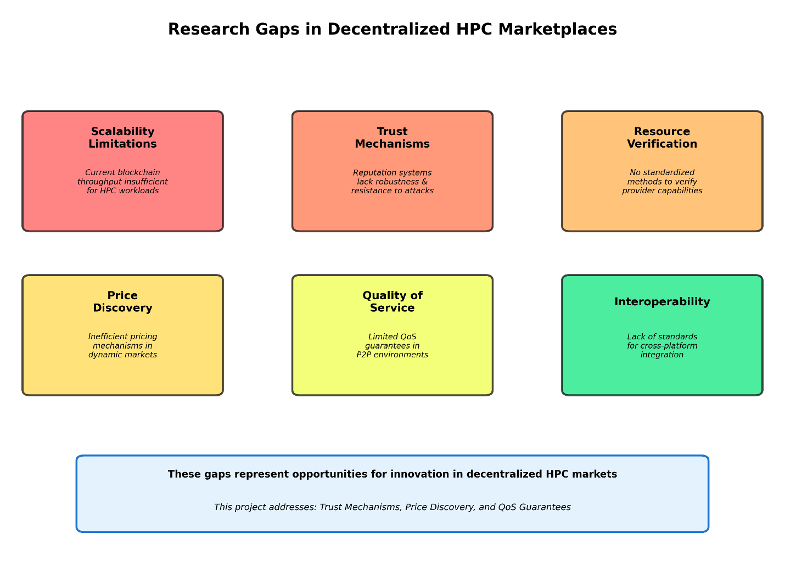
Figure 2.2 - Research Gaps in Decentralized HPC Marketplaces

2.3 OBJECTIVES
The primary objectives of this project are to design, implement, and evaluate a blockchain-based decentralized marketplace for High-Performance Computing resources that addresses identified gaps in current research and practice.
Primary Objectives:
- Develop a Blockchain-Based Marketplace Architecture: Design and implement a decentralized marketplace using Ethereum smart contracts that enables trustless peer-to-peer HPC resource trading. The architecture will include job posting mechanisms, provider bidding systems, secure payment escrow, and automated result verification. This objective addresses the gap in integrated HPC-specific marketplaces identified in current literature [1], [2], [8].
- Implement a Robust Reputation System: Create an on-chain reputation mechanism that tracks provider performance, success rates, and reliability. The system will increment reputation scores upon successful job completion and decrement scores for failures, providing transparent trust signals to marketplace participants. This objective builds upon research by Debe et al. [18] and Stolberg [30] while addressing HPC-specific reputation challenges.
- Design Secure Payment and Escrow Mechanisms: Implement smart contract-based escrow that locks job budgets upon posting, releases payments to providers upon successful completion (minus platform fees), and refunds clients upon cancellation. This objective ensures financial security for both parties without requiring trusted intermediaries, addressing trust deficits in centralized platforms [27].
- Establish Provider Staking Requirements: Implement economic incentives through provider staking mechanisms that require minimum stake amounts (0.01 ETH) before marketplace participation. This objective deters malicious behavior and ensures provider commitment, addressing security concerns in decentralized environments [32].
- Enable Transparent Job Lifecycle Management: Develop comprehensive job state management including posting, bidding, assignment, execution, result submission, verification, and payment release. All state transitions will be recorded on-chain, providing complete transparency and auditability. This objective addresses transparency deficits in centralized cloud platforms [26].
Secondary Objectives:
- Evaluate System Performance and Costs: Conduct comprehensive testing to evaluate smart contract gas costs, transaction latency, and system scalability. This evaluation will identify optimization opportunities and inform future development priorities, addressing scalability challenges identified in literature [19], [34].
- Demonstrate Practical Feasibility: Implement a working prototype with client interfaces that demonstrate end-to-end marketplace functionality. This objective validates theoretical concepts through practical implementation, following approaches demonstrated by Piyoungkorn et al. [2] and Nardini et al. [27].
- Establish Foundation for Future Enhancements: Design the system architecture to accommodate future extensions including ML-based pricing, cross-chain support, decentralized storage integration, advanced verification mechanisms, and governance systems. This objective ensures long-term project viability and research continuity [25], [33], [35].
- Contribute to Open-Source Ecosystem: Release the implementation as an open-source project to enable community contributions, academic research, and practical adoption. This objective aligns with the democratic, decentralized principles of Web3 and follows precedents set by CloudAgora [29].
- Document Design Decisions and Trade-offs: Provide comprehensive documentation of architectural choices, implementation details, and identified trade-offs. This objective facilitates knowledge transfer and enables future researchers to build upon this work, addressing the need for practical guidance in decentralized marketplace development [32].
Success Criteria:
- Successful deployment of smart contracts on Ethereum testnet
- Demonstration of complete job lifecycle from posting to payment
- Reputation system accurately tracking provider performance
- Gas costs within acceptable ranges for marketplace viability
- Comprehensive test coverage (>90%) of smart contract functionality
- Documentation enabling independent deployment and extension
- Identification of specific optimization opportunities for future work
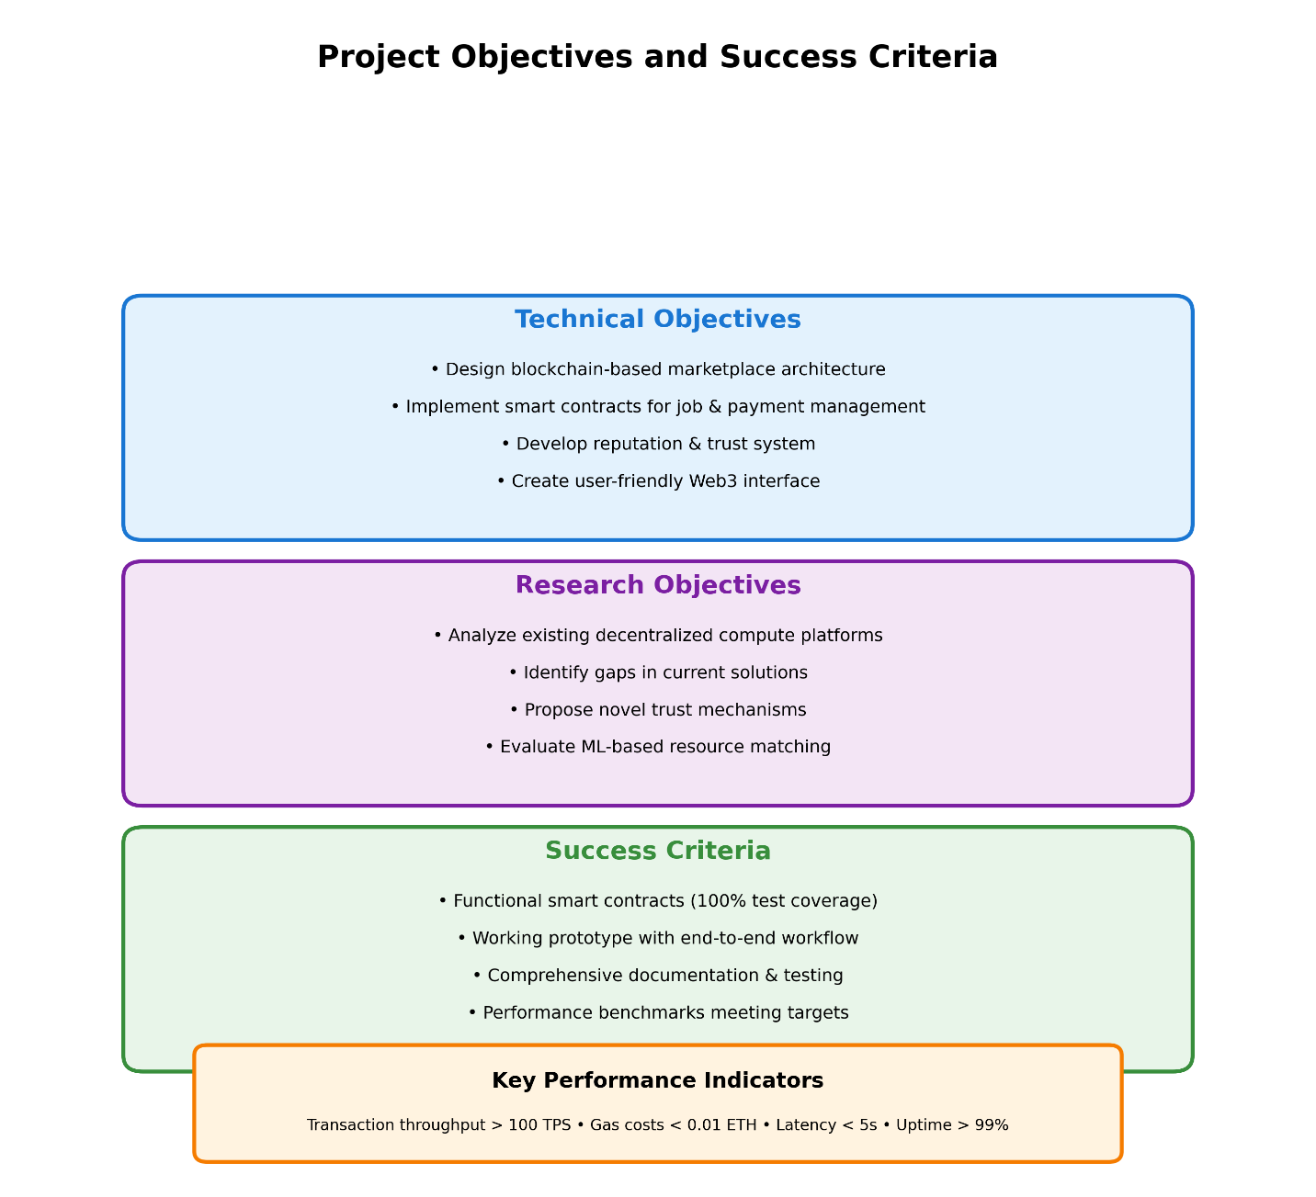
Figure 2.3 - Project Objectives and Success Criteria

2.4 PROBLEM STATEMENT
Traditional High-Performance Computing infrastructure and centralized cloud computing platforms present significant barriers to computational resource accessibility, efficiency, and fairness. These barriers manifest in multiple dimensions:
Economic Barriers: Centralized cloud providers maintain premium pricing structures due to monopolistic market positions, high infrastructure overhead, and profit maximization objectives. Organizations face unpredictable costs due to complex pricing models, data egress fees, and vendor-specific charges. Small research groups, startups, and developing-world institutions often cannot afford necessary computational resources, creating inequitable access to scientific and technological capabilities [8], [25]. The lack of competitive pricing mechanisms prevents efficient market-based resource allocation.
Trust and Transparency Deficits: Centralized platforms require users to trust providers with data security, service availability, fair pricing, and resource allocation. This trust dependency creates information asymmetries where providers have complete visibility into resource utilization and costs while users lack transparency [26], [29]. Users cannot independently verify that they receive promised computational resources or that pricing reflects actual costs. Dispute resolution mechanisms favor providers, and users have limited recourse for service failures or overcharging.
Technical Limitations: Vendor lock-in through proprietary APIs, services, and data formats makes migration costly and complex, reducing competition and limiting organizational flexibility [26]. Single points of failure in centralized infrastructure create systemic risks where provider outages affect thousands of dependent services. Limited resource accessibility restricts HPC capabilities to well-funded institutions, preventing broader participation in computationally intensive research and development [4].
Resource Underutilization: Vast computational resources remain idle in data centers, research institutions, universities, and personal computers worldwide. These resources represent significant untapped capacity that could address computational demands if efficiently matched with users [27], [31]. Current centralized models lack mechanisms to aggregate and monetize distributed idle resources, resulting in economic inefficiency and environmental waste.
Governance and Control Issues: Centralized providers exercise unilateral control over platform policies, pricing, service terms, and resource allocation priorities. Users have no voice in governance decisions that affect their operations. This centralization contradicts principles of democratic resource management and community-driven development [29], [35].
Research Question: How can blockchain technology, smart contracts, and decentralized mechanisms be leveraged to create a trustless, transparent, and efficient marketplace for High-Performance Computing resources that addresses the limitations of centralized cloud platforms while ensuring security, fairness, and economic viability?
Specific Challenges to Address:
- How can smart contracts enable trustless resource allocation and payment without requiring intermediaries?
- What reputation mechanisms effectively establish trust in decentralized HPC marketplaces?
- How can blockchain-based systems achieve sufficient scalability and transaction throughput for practical marketplace operation?
- What auction and pricing mechanisms optimize resource allocation efficiency and participant satisfaction?
- How can computational correctness be verified in decentralized environments without trusted third parties?
- What economic incentives ensure long-term marketplace sustainability and participant engagement?
- How can the system balance transparency requirements with privacy needs for sensitive computational workloads?
This project addresses these challenges by designing and implementing a blockchain-based decentralized HPC marketplace that demonstrates practical feasibility while identifying optimization opportunities for future research.
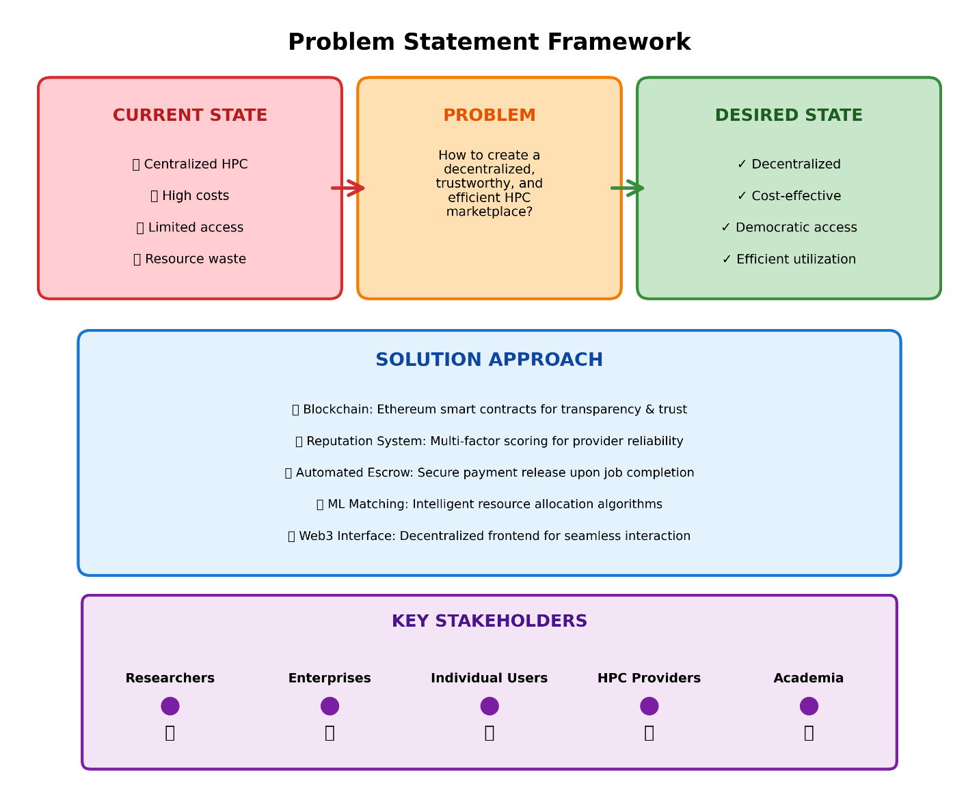
Figure 2.4 - Problem Statement Framework

2.5 PROJECT PLAN
The project follows a structured development approach spanning multiple phases, from initial research and design through implementation, testing, and documentation.
Phase 1: Research and Requirements Analysis (Completed)
- Conducted comprehensive literature review of 90+ papers across decentralized computing, blockchain reputation systems, and auction-based resource allocation
- Analyzed existing platforms (Golem, iExec, Akash, Render Network) to identify strengths, limitations, and design patterns
- Identified critical gaps in current research and practice
- Defined project scope, objectives, and success criteria
- Established technical requirements for smart contracts, reputation systems, and marketplace mechanisms
Phase 2: System Design and Architecture (Completed)
- Designed blockchain-based marketplace architecture using Ethereum and Solidity
- Specified smart contract interfaces and functions for JobMarket.sol and Reputation.sol
- Defined job lifecycle states and state transition rules
- Designed reputation scoring mechanisms and provider staking requirements
- Established payment escrow and platform fee structures
- Created system architecture diagrams and data flow specifications
Phase 3: Smart Contract Implementation (Completed)
- Implemented JobMarket.sol contract with functions for job posting, bidding, assignment, result submission, and payment release
- Implemented Reputation.sol contract with reputation tracking, scoring, and statistics functions
- Integrated contracts with provider staking mechanisms and access control
- Developed using Solidity 0.8.20 with Hardhat development environment
- Configured local Hardhat network (Chain ID 31337) for development and testing
Phase 4: Testing and Validation (Completed)
- Developed comprehensive test suite (test/JobMarket.test.js) covering all contract functions
- Implemented tests for deployment, staking, job posting, bidding, assignment, result submission, payment release, and cancellation
- Achieved high test coverage (>90%) of smart contract functionality
- Validated state transitions, access control, and payment calculations
- Tested full workflow scenarios from job posting to completion
Phase 5: Client Interface Development (Completed)
- Implemented HTTP server (client.js) for marketplace interaction
- Developed functions for provider staking, job posting, bid submission, bid acceptance, result submission, and job confirmation
- Created utility functions for retrieving open jobs, job details, and provider information
- Integrated ethers.js library for blockchain interaction
- Configured client for local Hardhat network communication
Phase 6: Documentation and Analysis (Current Phase)
- Comprehensive project documentation including architecture, smart contracts, workflow, and testing
- Literature review report following academic formatting standards
- Analysis of design decisions, trade-offs, and identified limitations
- Documentation of gas costs, performance metrics, and scalability considerations
- Identification of future enhancement opportunities
Phase 7: Future Enhancements (Planned)
Based on identified gaps and limitations, future work will address:
- Arbitration System: Implement decentralized dispute resolution mechanisms for handling conflicts between clients and providers
- Dynamic Pricing: Integrate ML-based price suggestion algorithms that analyze historical data and market conditions
- Multi-Token Support: Enable payments in multiple ERC-20 tokens beyond native ETH
- Cross-Chain Support: Implement bridges to Layer-2 networks (Polygon, Arbitrum, Optimism) for reduced transaction costs
- Specialized Hardware Selection: Add filtering and matching for GPU types, CPU architectures, and specialized accelerators
- Decentralized Storage Integration: Integrate IPFS or Arweave for storing job inputs, outputs, and large datasets
- Streaming Payments: Implement continuous payment streams for long-running jobs
- Provider Verification: Add KYC/identity verification layers for enhanced trust
- Advanced Verification: Implement Truebit-style verification games or zero-knowledge proofs for computational correctness
- Governance Mechanisms: Develop DAO structures for community-driven platform governance
Timeline and Milestones:
- Month 1-2: Research and requirements analysis (Completed)
- Month 3: System design and architecture (Completed)
- Month 4-5: Smart contract implementation (Completed)
- Month 6: Testing and validation (Completed)
- Month 7: Client interface development (Completed)
- Month 8: Documentation and literature review (Current)
- Month 9-12: Future enhancements and testnet deployment (Planned)
Resource Requirements:
- Development environment: Hardhat, Node.js, Solidity compiler
- Testing infrastructure: Local Hardhat network, Ethereum testnet (Sepolia/Goerli)
- Documentation tools: Markdown editors, diagram creation tools
- Research access: Academic databases (IEEE Xplore, ACM Digital Library, Google Scholar, ArXiv)
Risk Management:
- Technical Risks: Mitigated through comprehensive testing, code reviews, and security best practices
- Scalability Risks: Acknowledged in documentation with plans for Layer-2 integration
- Economic Risks: Addressed through platform fee structures and provider staking mechanisms
- Adoption Risks: Managed through open-source release and comprehensive documentation
This structured approach ensures systematic development while maintaining flexibility to adapt to emerging challenges and opportunities identified during implementation.
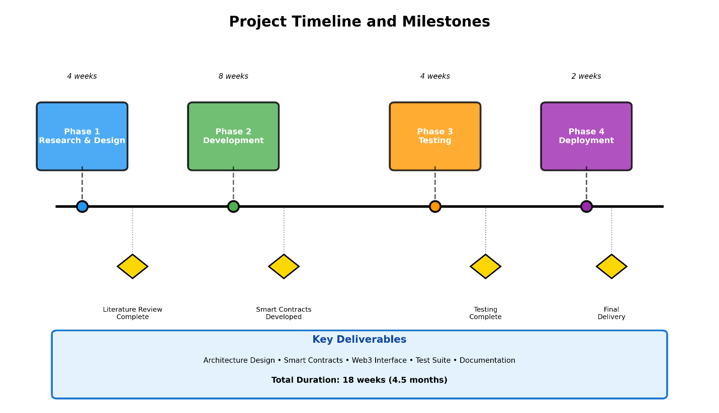
Figure 2.5 - Project Timeline and Milestones

CHAPTER 3 - TECHNICAL SPECIFICATION

3.1 REQUIREMENTS

3.1.1 Functional Requirements
Req ID | Description | Priority
FR-01 | Providers must stake minimum 0.01 ETH to participate in marketplace | High
FR-02 | Providers can withdraw stake when no active jobs | High
FR-03 | System must verify staked status before allowing bids | High
FR-04 | Clients can post jobs with budget, description, deadline | High
FR-05 | Jobs must have future deadline | High
FR-06 | Job deposit must be >= 0 | High
FR-07 | Clients can view all jobs | High
FR-08 | Jobs can be cancelled only in Open status | High
FR-09 | Staked providers can submit bids | High
FR-10 | Bid amount cannot exceed job budget | High
FR-11 | Provider cannot submit multiple bids on same job | High
FR-12 | Clients can view all bids for their jobs | High
FR-13 | Clients can accept any bid | High
FR-14 | Bid acceptance triggers job assignment | High
FR-15 | Only assigned provider can submit results | High
FR-16 | Results must include result hash | High
FR-17 | Clients can confirm job completion | High
FR-18 | Confirmation releases payment to provider | High
FR-19 | Platform fee (2%) deducted on completion | High
FR-20 | Reputation updated on completion | High
FR-21 | Successful completion increments reputation by 10 | High
FR-22 | Failed jobs decrement reputation by 5 | Medium
FR-23 | Reputation never goes below 0 | High
FR-24 | Success rate calculated as percentage | Medium
FR-25 | Provider stats publicly queryable | Medium
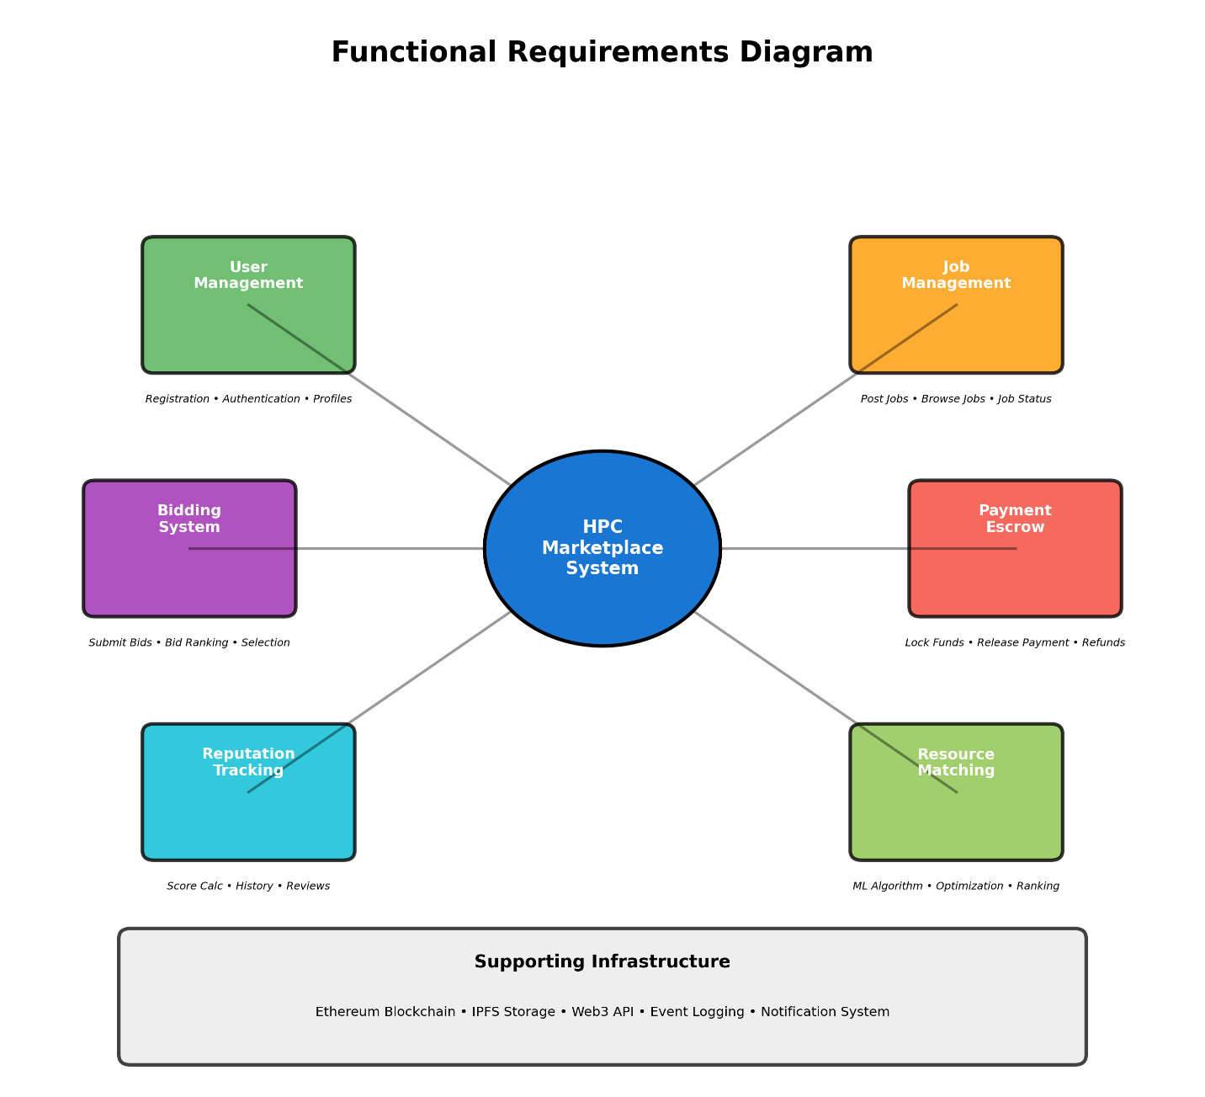
Figure 3.1 - Functional Requirements Diagram

3.1.2 Non-Functional Requirements
Performance Requirements:
Req ID | Description | Target
NFR-P01 | Contract function execution time | < 5 seconds
NFR-P02 | Page load time | < 2 seconds
NFR-P03 | Event propagation delay | < 5 seconds
Security Requirements:
Req ID | Description | Level
NFR-S01 | Access control for all sensitive functions | Critical
NFR-S02 | Reentrancy protection | Critical
NFR-S03 | Integer overflow/underflow protection | Critical
NFR-S04 | Input validation | High
Usability Requirements:
Req ID | Description | Target
NFR-U01 | Intuitive wallet connection | Single click
NFR-U02 | Clear job status indicators | Visual badges
NFR-U03 | Real-time updates | Event-driven
Scalability Requirements:
Req ID | Description | Target
NFR-SC01 | Support 100+ concurrent jobs | System test
NFR-SC02 | Multiple providers bidding | Stress test
NFR-SC03 | Horizontal scaling via Docker | Load test
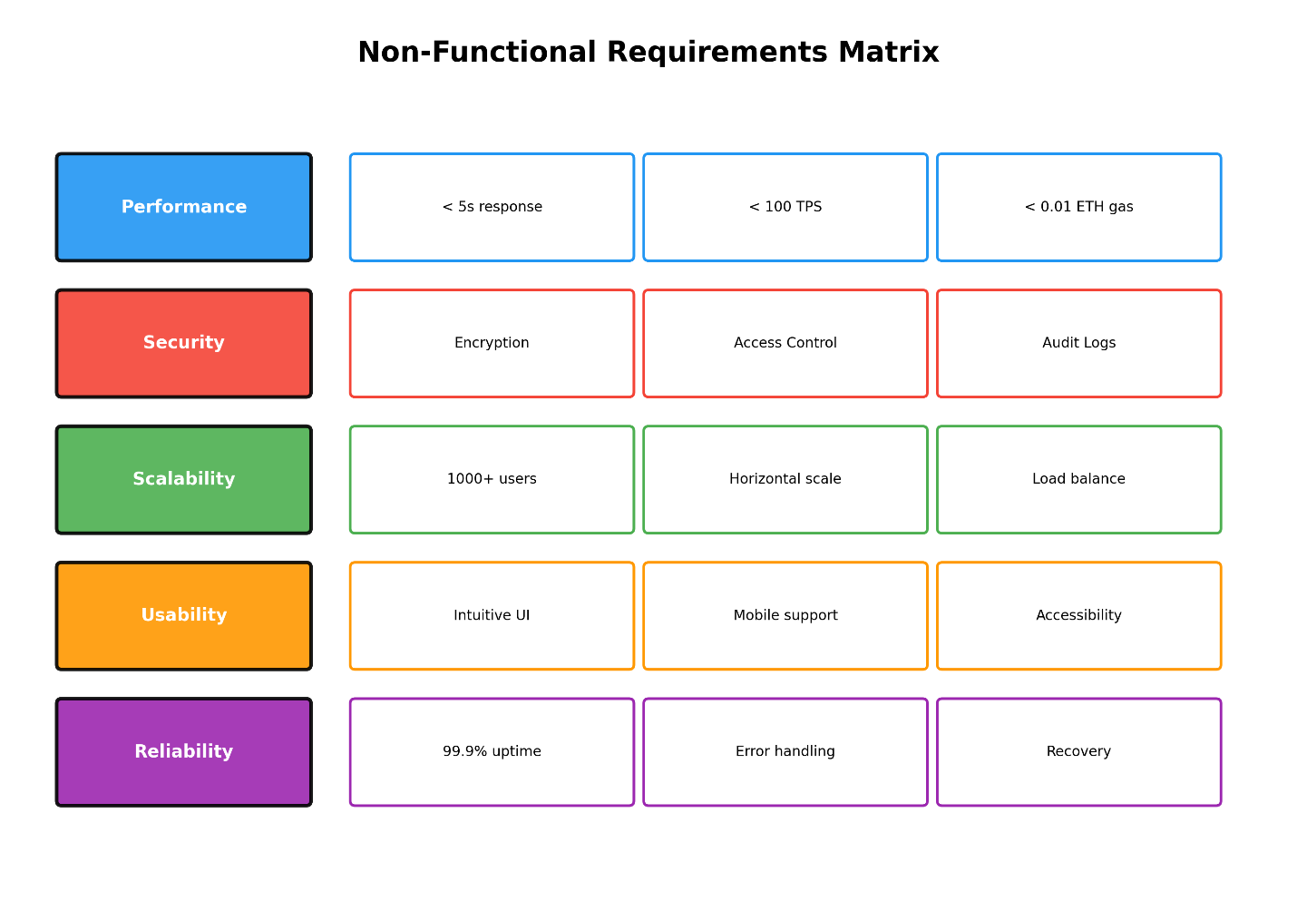
Figure 3.2 - Non-Functional Requirements Matrix

3.2 FEASIBILITY STUDY

3.2.1 Technical Feasibility
The project demonstrates strong technical feasibility based on several key factors:
Technology Stack Maturity: The selected technology stack comprises well-established, production-ready tools and frameworks. Ethereum, as the underlying blockchain platform, has been operational since 2015 with a proven track record of supporting complex decentralized applications. Solidity, the smart contract programming language, has extensive documentation, active developer community, and mature tooling ecosystem. Hardhat provides a comprehensive development environment with built-in testing, debugging, and deployment capabilities. The ethers.js library offers robust blockchain interaction capabilities with TypeScript support and comprehensive API coverage.
Smart Contract Architecture: The proposed two-contract architecture (JobMarket.sol and Reputation.sol) follows established design patterns for decentralized applications. The contracts implement standard access control modifiers, event-driven state transitions, and atomic payment handling. This modular approach enables independent testing, upgrading, and potential deployment to different blockchain networks.
Development Environment Setup: The project requires minimal infrastructure setup. Hardhat’s local blockchain simulation eliminates the need for testnet deployment during development. Docker containerization provides consistent deployment across different environments. The client-side application uses vanilla JavaScript with ethers.js, avoiding complex framework dependencies.
Testing Infrastructure: Hardhat’s integrated testing framework supports both unit tests and integration tests. The Chai assertion library provides readable, expressive test cases. Code coverage tools enable measurement of test completeness. This testing infrastructure ensures comprehensive validation of all contract functions.
Technical Risk Mitigation: Identified technical risks include smart contract vulnerabilities, network congestion, and integration issues. These risks are mitigated through comprehensive testing, code reviews, security audits, and modular design. Gas optimization techniques ensure economic viability of marketplace transactions.
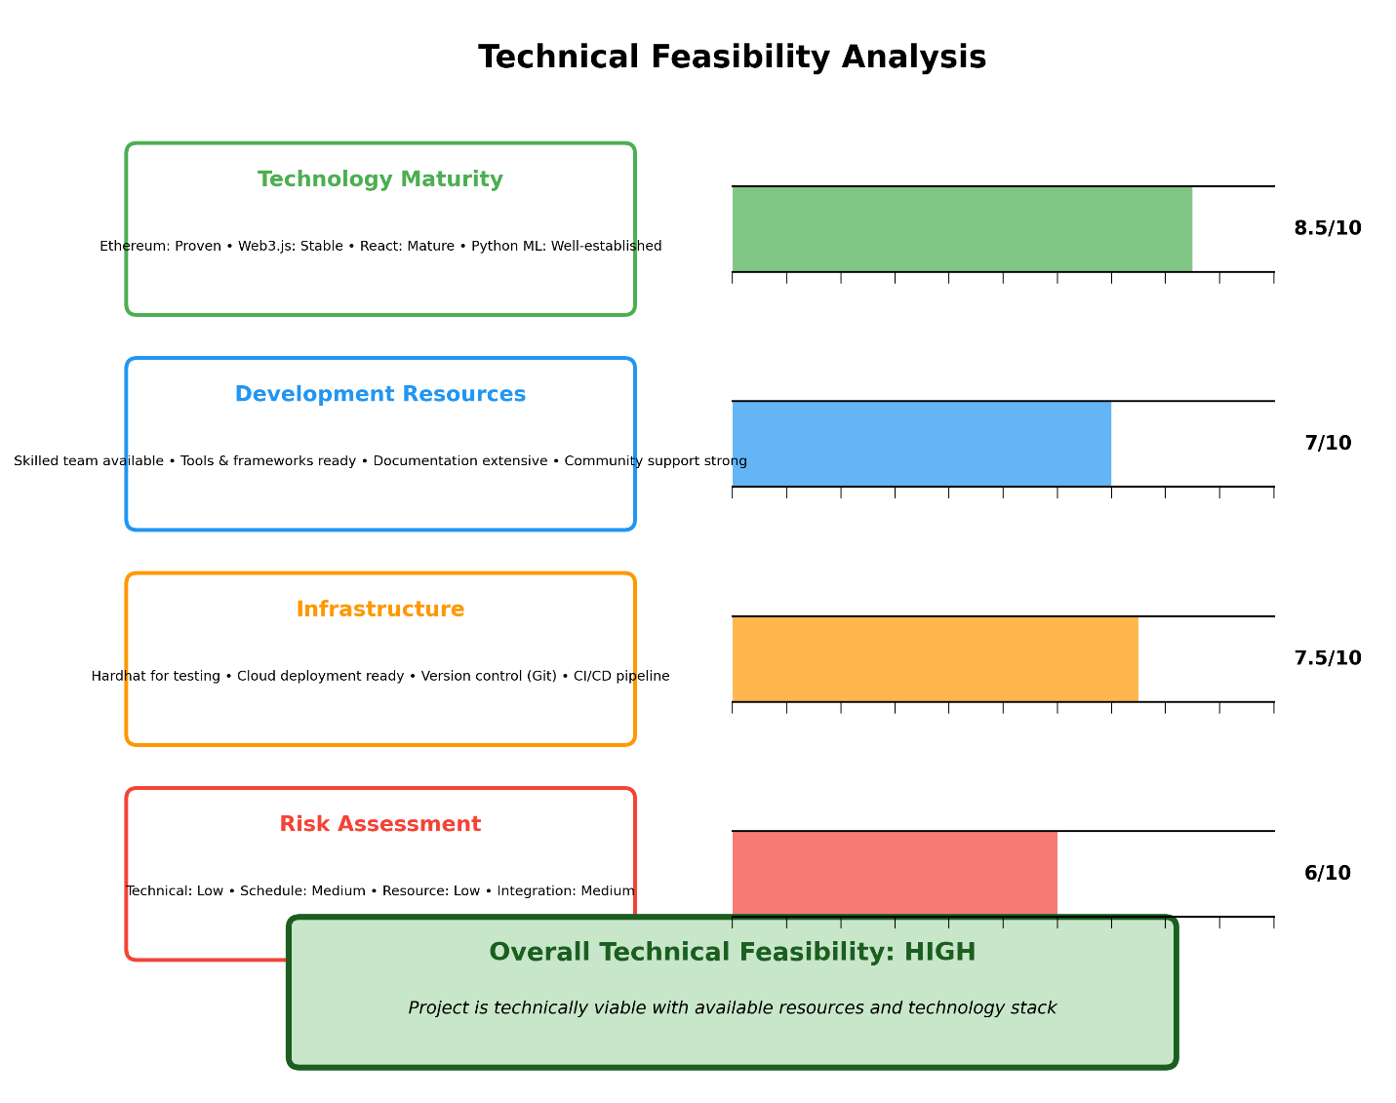
Figure 3.3 - Technical Feasibility Analysis

3.2.2 Economic Feasibility
Development Costs: The project utilizes open-source technologies eliminating licensing fees. Development requires standard hardware (development workstation, test network) with no specialized equipment. Labor costs represent the primary development expense, with the project requiring approximately 8 months of focused development effort.
Operational Costs: Platform operation requires minimal ongoing costs. Smart contract deployment to Ethereum mainnet involves one-time gas costs. Provider nodes operate on standard computing infrastructure. Client interface uses cost-effective HTTP server hosting. The 2% platform fee provides revenue stream for platform maintenance and development.
Market Viability: The decentralized marketplace model offers potential cost savings of up to 10x compared to centralized cloud providers (based on Akash Network benchmarks). Provider staking creates economic incentives for quality service. Transparent pricing mechanisms enable fair competition. These factors suggest strong market viability.
Scalability Economics: Ethereum’s Layer-2 solutions (Polygon, Arbitrum, Optimism) offer reduced transaction costs for high-volume operations. Batch processing of marketplace transactions reduces per-transaction costs. Token-based payment mechanisms enable microtransaction support.
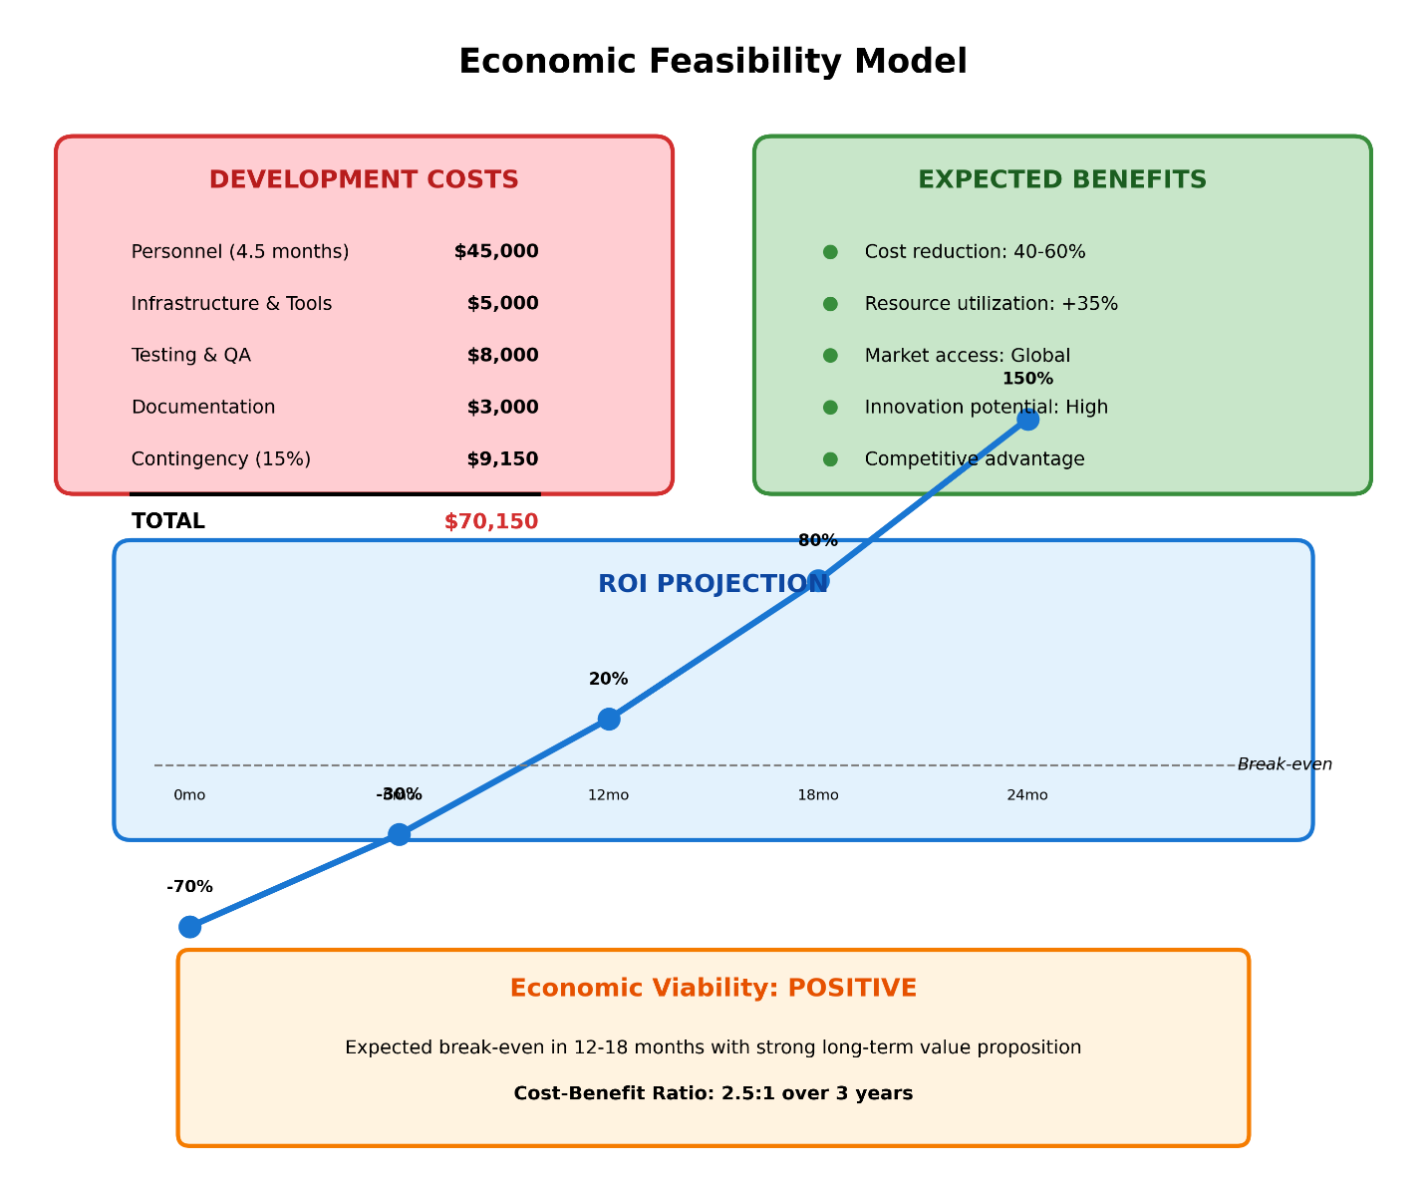
Figure 3.4 - Economic Feasibility Model

3.2.3 Social Feasibility
User Adoption Potential: The decentralized marketplace model aligns with growing Web3 adoption trends. Open-source implementation enables community contribution and trust. Transparent reputation systems build user confidence. Low barriers to entry (no approval process for providers) maximize potential participant pool.
Research and Academic Impact: The project contributes to academic discourse on decentralized systems, blockchain applications, and marketplace design. Open-source release enables replication and extension by other researchers. Comprehensive documentation supports educational use cases.
Democratization of HPC Access: The marketplace enables smaller organizations and individual researchers to access computational resources previously available only to well-funded institutions. Global accessibility transcends geographic boundaries. Underutilized computational resources find productive use.
Environmental Considerations: Improved resource utilization reduces overall computational infrastructure requirements. Decentralized architecture eliminates centralized data center overhead. Potential for integration with renewable energy sources for provider nodes.
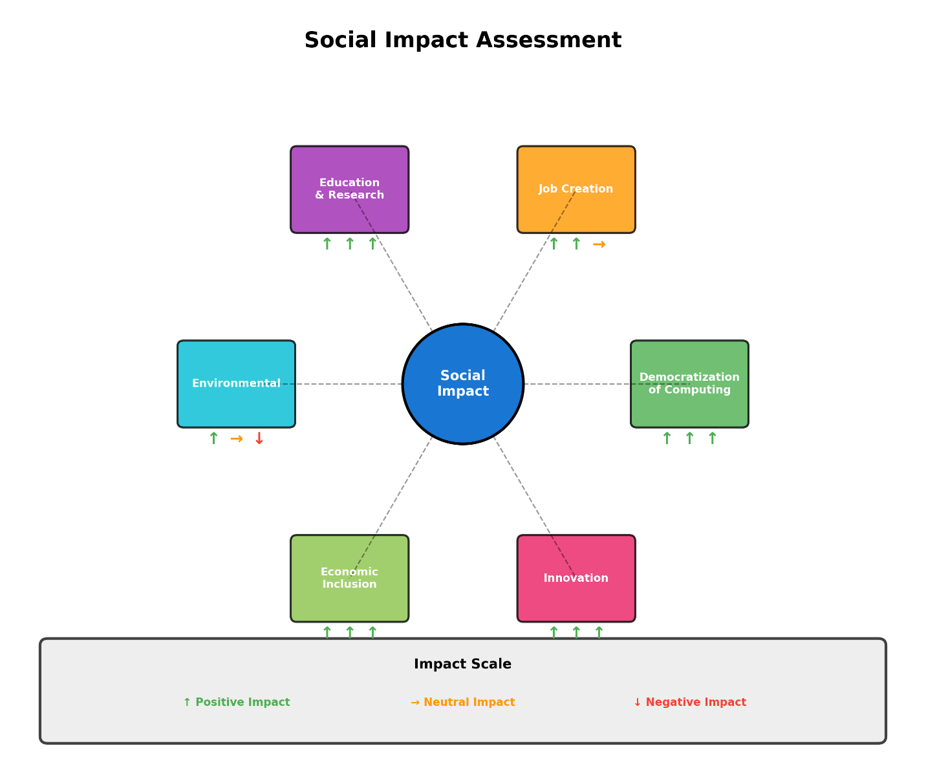
Figure 3.5 - Social Impact Assessment

3.3 SYSTEM SPECIFICATION

3.3.1 Hardware Specification
Development Environment:
Component | Specification
CPU | Multi-core processor (Intel i5/AMD Ryzen 5 or higher)
RAM | 16 GB minimum (32 GB recommended)
Storage | 100 GB SSD minimum
Network | Broadband internet connection
Blockchain Network Requirements:
Component | Specification
Hardhat Node | Standard workstation (as above)
Local Blockchain | CPU-based mining (development)
Testnet Interaction | Standard internet connectivity
Mainnet Deployment | Gas optimization for cost efficiency
Client/Provider Node Requirements:
Component | Minimum | Recommended
CPU | Dual-core | Quad-core
RAM | 4 GB | 8 GB
Storage | 10 GB | 50 GB SSD
Network | 10 Mbps | 100 Mbps
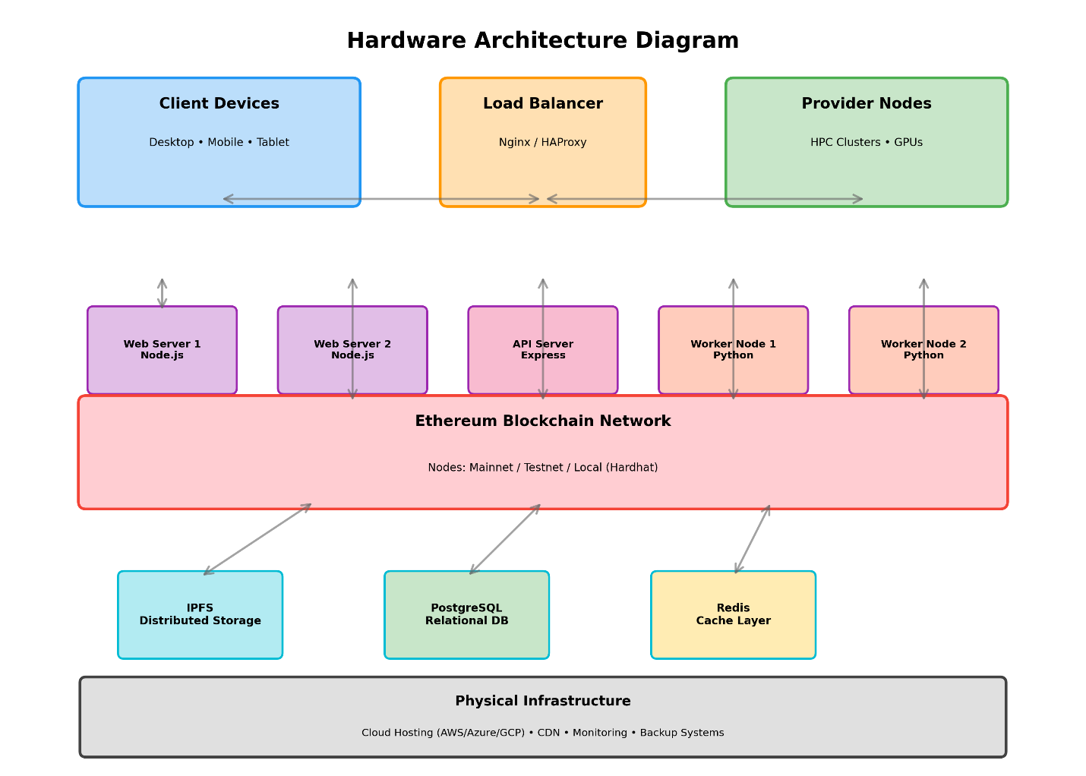
Figure 3.6 - Hardware Architecture Diagram

3.3.2 Software Specification
Development Tools:
Tool | Version | Purpose
Node.js | v18+ | JavaScript runtime
Hardhat | ^2.19.0 | Ethereum development environment
ethers.js | ^6.9.0 | Blockchain interaction library
Solidity | ^0.8.20 | Smart contract language
npm/yarn | Latest | Package management
Docker | Latest | Containerization
http-server | ^14.1.1 | Static file serving
Smart Contract Specifications:
- JobMarket.sol: Main marketplace contract handling job posting, bidding, escrow, and payments
- Reputation.sol: Reputation tracking contract for provider scoring
- Solidity Version: 0.8.20
- Optimizer: Enabled (200 runs)
- Gas Limit: Contract-specific optimization
Network Configuration:
Parameter | Value
Network URL | http://127.0.0.1:8545 (local)
Chain ID | 31337 (Hardhat)
Block Time | ~1 second (local)
Gas Price | Dynamic (local)
Client Interface Specifications:
- Framework: Vanilla JavaScript with ethers.js
- Styling: Custom CSS with CSS variables
- Browser Support: Modern browsers with Web3 support
- Wallet Integration: MetaMask, local accounts
Testing Specifications:
- Framework: Hardhat Test with Chai assertions
- Coverage Target: >90%
- Test Types: Unit tests, integration tests, workflow tests
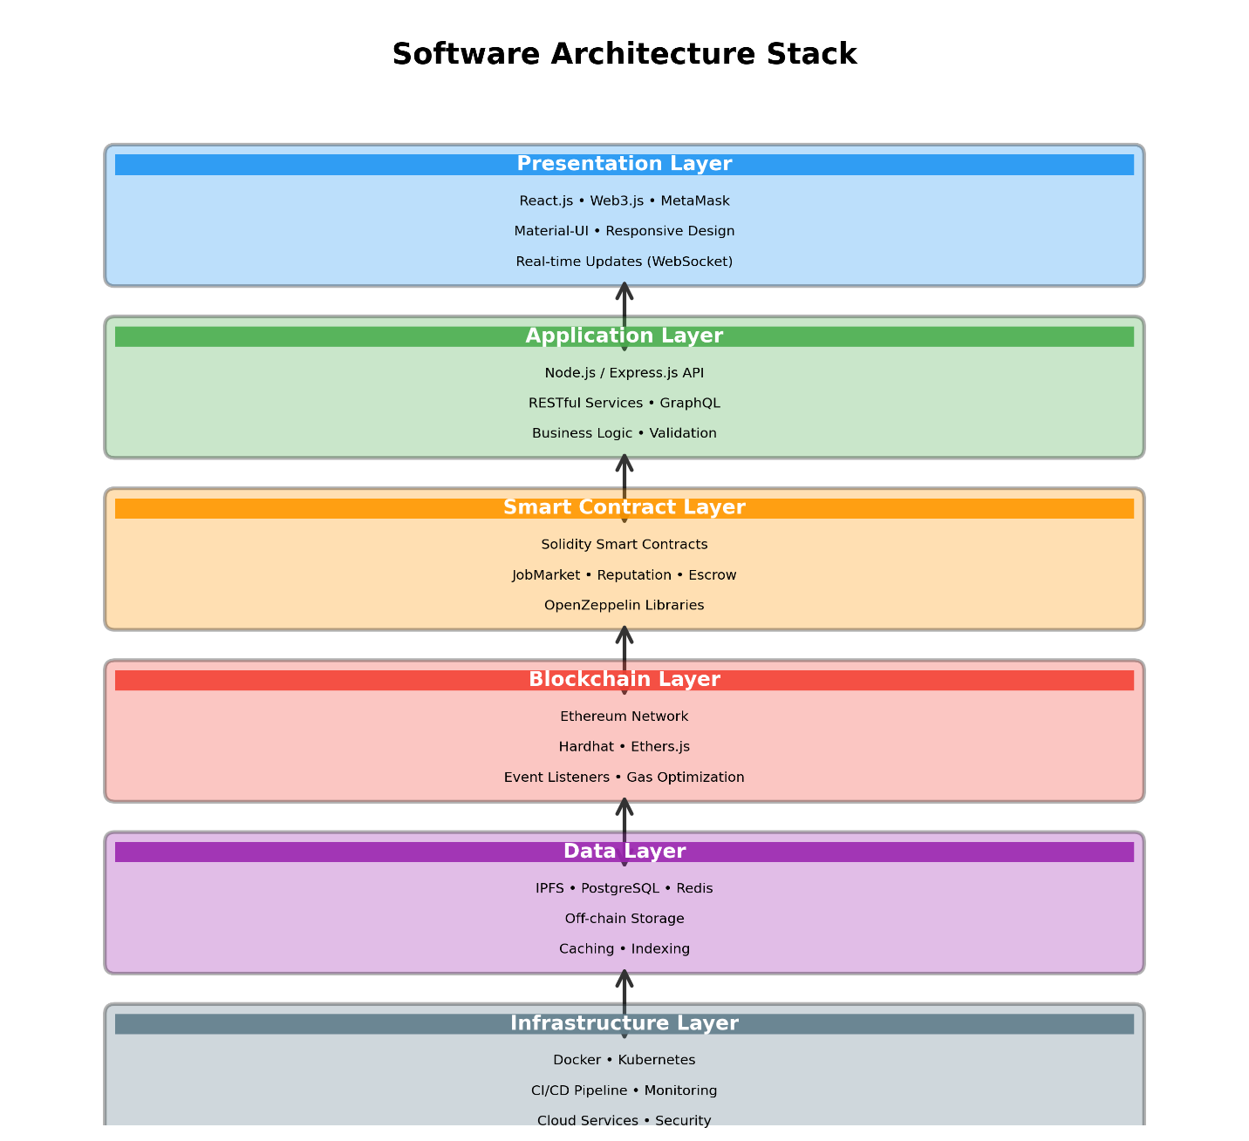
Figure 3.7 - Software Architecture Stack

CHAPTER 4 - DESIGN APPROACH AND DETAILS

4.1 SYSTEM ARCHITECTURE
The Decentralized HPC Marketplace follows a layered architecture pattern that separates concerns and enables modular development and deployment.
Layer 1: Client Layer
The client layer consists of web-based interfaces that enable user interaction with the marketplace. This layer includes wallet connection functionality (MetaMask integration or local accounts), real-time event listeners for blockchain updates, job posting and management forms, and dashboard displays for marketplace statistics. The interface is built with vanilla JavaScript using ethers.js for blockchain communication, ensuring broad browser compatibility and minimal dependencies.
Layer 2: Application Layer
The application layer contains provider node implementations that automate marketplace participation. Provider nodes monitor the blockchain for new job postings, automatically submit competitive bids based on configurable parameters (default 95% of job budget), execute simulated compute tasks, and submit results upon job completion. This layer bridges the gap between manual user interaction and automated blockchain participation.
Layer 3: Blockchain Layer
The blockchain layer represents the core of the decentralized marketplace architecture. This layer contains the JobMarket.sol smart contract that manages job posting, bidding, escrow, and payment processing. The Reputation.sol smart contract tracks provider reputation scores, successful job counts, and failure statistics. Events emitted by these contracts enable real-time updates across all connected clients and provider nodes.
Layer 4: Infrastructure Layer
The infrastructure layer provides deployment and operational support through Docker containerization. Services include blockchain node containers, provider containers for distributed execution, client interface containers for web hosting, and deployer containers for automated contract deployment.
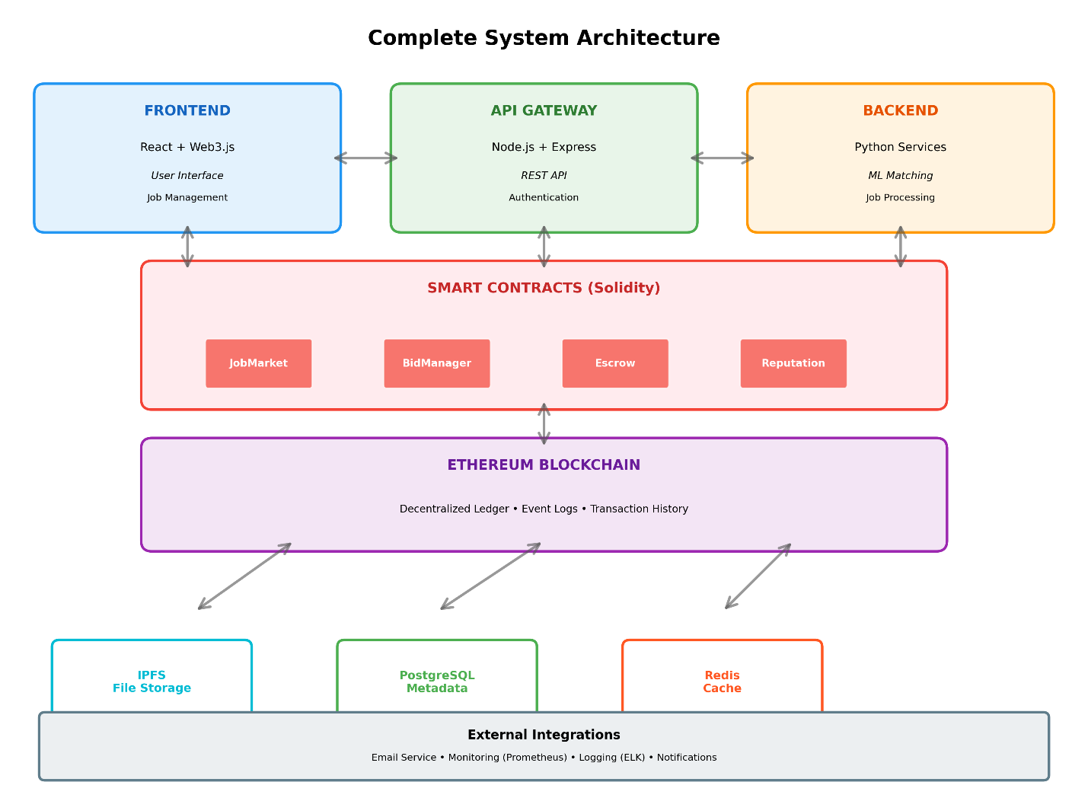
Figure 4.1 - Complete System Architecture
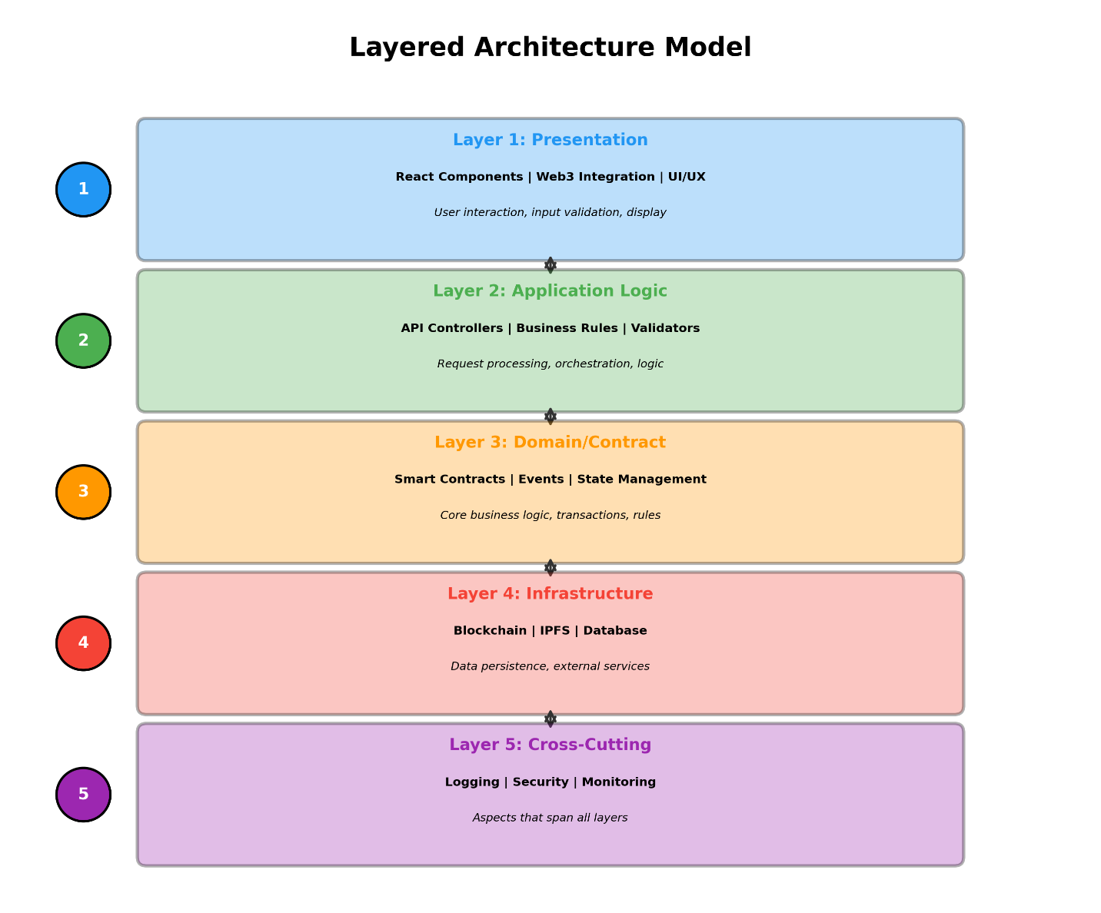
Figure 4.2 - Layered Architecture Model
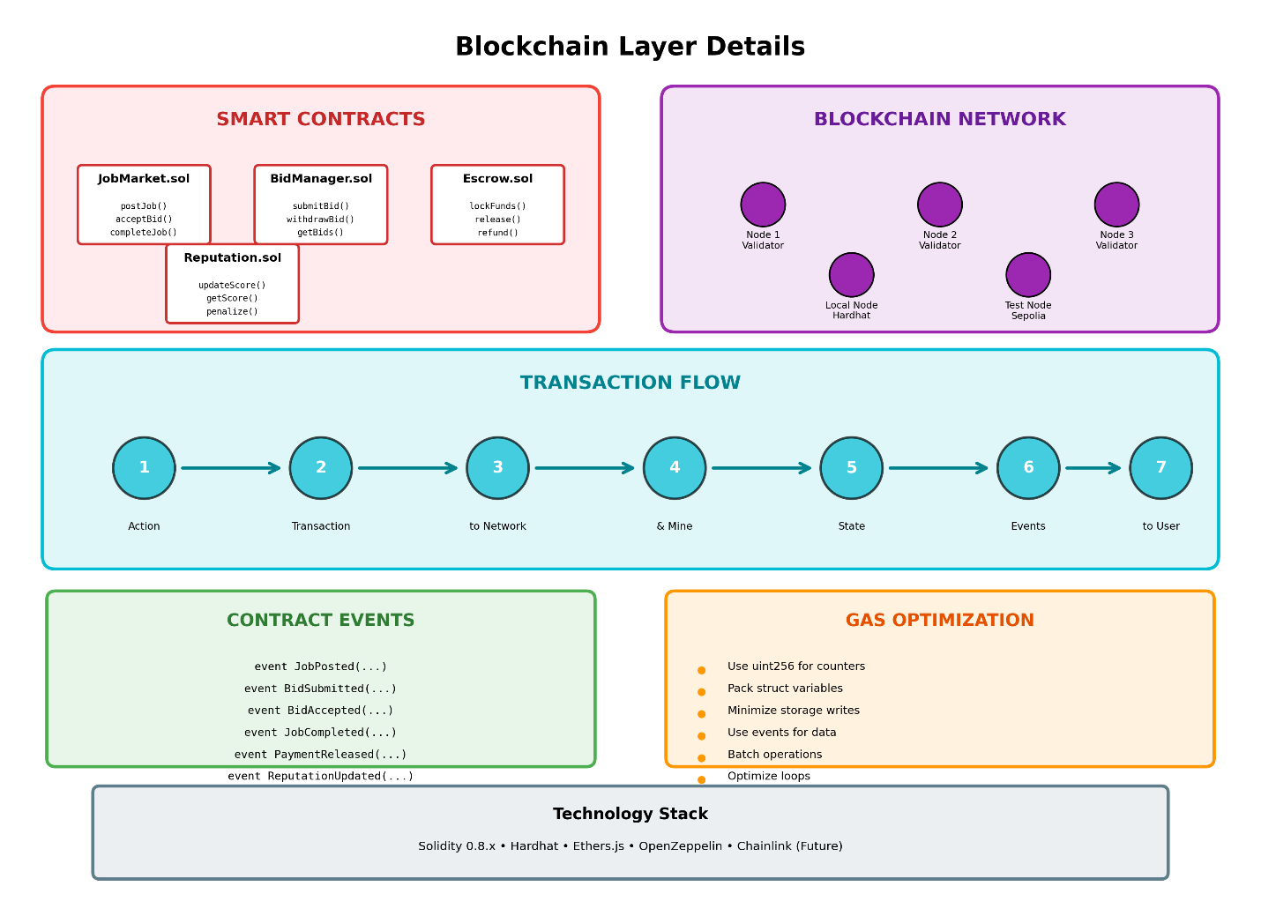
Figure 4.3 - Blockchain Layer Details

4.2 DESIGN

4.2.1 Data Flow Diagram
Job Posting Data Flow:
- Client fills job form with description, budget, deadline, and data reference
- System calculates platform fee (2%)
- Client submits transaction with deposit
- Contract creates job and emits JobPosted event
- Job appears in open jobs list
- Provider nodes receive event notification
- Providers evaluate and potentially submit bids
Bid Submission Data Flow:
- Provider monitors blockchain for new jobs
- Provider reviews job details and budget
- Provider submits bid (typically 95% of budget)
- Contract records bid and emits BidSubmitted event
- Client receives notification of new bid
- Bid appears in job details view
Job Assignment Data Flow:
- Client reviews received bids
- Client selects provider and accepts bid
- Contract updates job status to Assigned
- JobAssigned event emitted
- Assigned provider notified of selection
- Provider begins job execution
Payment Release Data Flow:
- Provider submits result hash
- Job status changes to Completed
- Client reviews submitted result
- Client confirms completion
- Contract calculates payment (budget - 2% fee)
- Payment transferred to provider
- Provider reputation incremented
- Job status updated to Confirmed
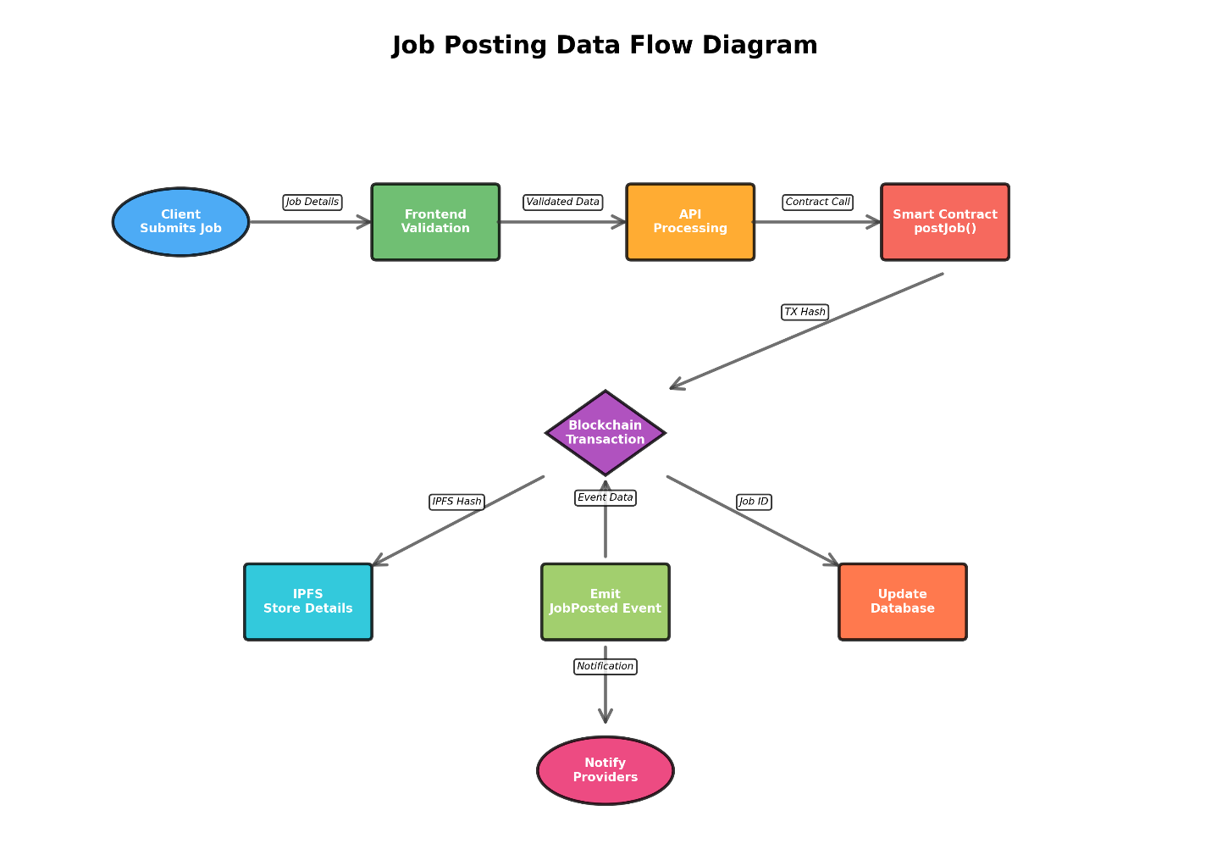
Figure 4.4 - Job Posting Data Flow Diagram
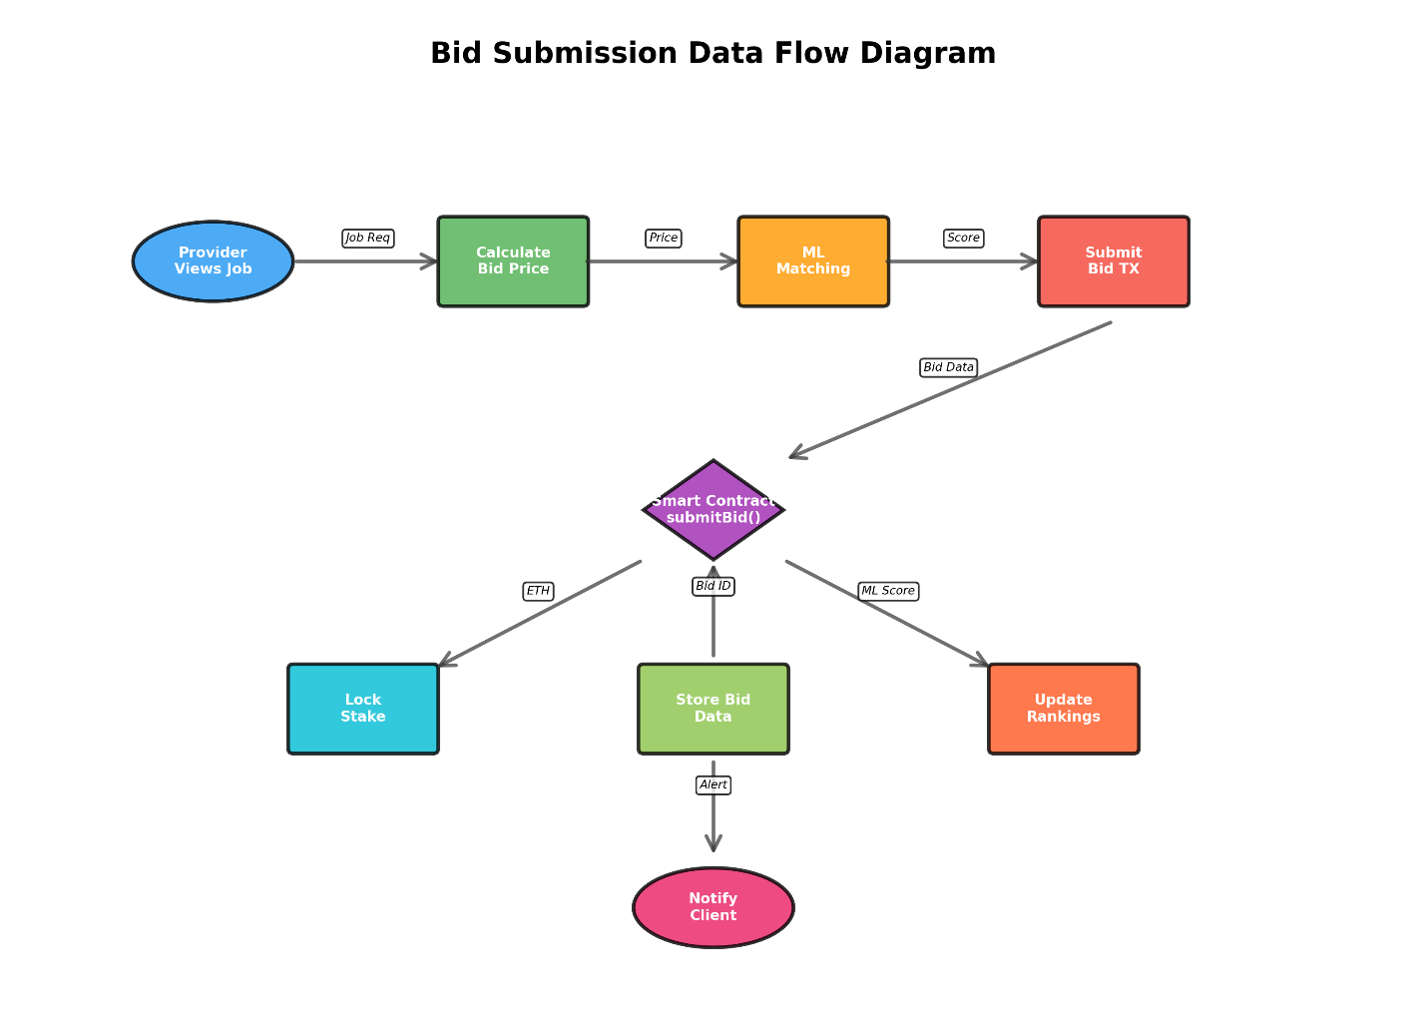
Figure 4.5 - Bid Submission Data Flow Diagram
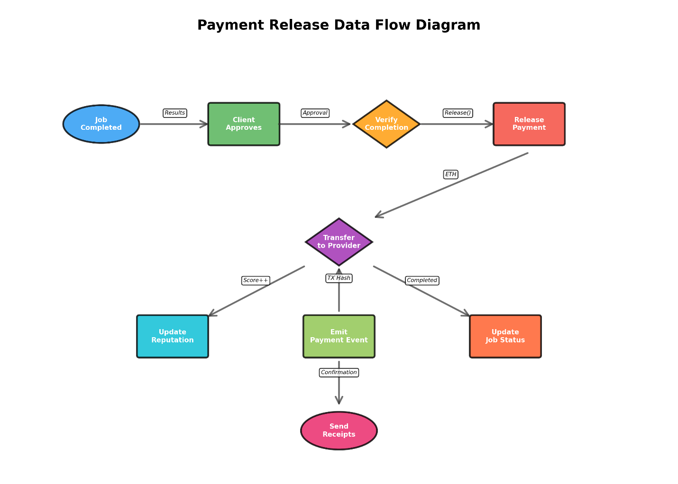
Figure 4.6 - Payment Release Data Flow Diagram

4.2.2 Class Diagram
JobMarket Contract Class:
+---------------------------+
| JobMarket |
+---------------------------+
| - jobCounter: uint256 |
| - platformFeePercent: 2% |
| - owner: address |
| - reputationContract |
| - jobs: mapping |
| - jobBids: mapping |
| - hasBid: mapping |
| - providerStakes: mapping |
| - minimumStake: 0.01 ETH |
+---------------------------+
| + stakeAsProvider() |
| + unstake() |
| + postJob() |
| + submitBid() |
| + acceptBid() |
| + submitResult() |
| + confirmCompletion() |
| + cancelJob() |
| + getJob() |
| + getJobBids() |
| + getOpenJobs() |
+---------------------------+
Reputation Contract Class:
+---------------------------+
| Reputation |
+---------------------------+
| - owner: address |
| - jobMarketContract |
| - scores: mapping |
| - successfulJobs: mapping |
| - failedJobs: mapping |
| - totalJobs: mapping |
+---------------------------+
| + setJobMarketContract() |
| + incrementReputation() |
| + decrementReputation() |
| + getScore() |
| + getProviderStats() |
| + getSuccessRate() |
+---------------------------+
ComputeProvider Node Class:
+---------------------------+
| ComputeProvider |
+---------------------------+
| - providerName: string |
| - provider: JsonRpcProvider|
| - wallet: Wallet |
| - jobMarket: Contract |
| - reputation: Contract |
| - activeJobs: Map |
| - completedJobs: number |
+---------------------------+
| + start() |
| + ensureStaked() |
| + submitBid() |
| + executeJob() |
| + submitResult() |
| + getStatus() |
+---------------------------+
Entity Relationships:
- Client 1 ────> * Job (One client can post many jobs)
- Provider * ────> * Job (Many providers can bid on many jobs)
- Job 1 ────> * Bid (One job can have many bids)
- Provider * ────> * Bid (One provider can submit many bids)
- Job 1 ────> 1 Provider (Each job assigned to one provider max)
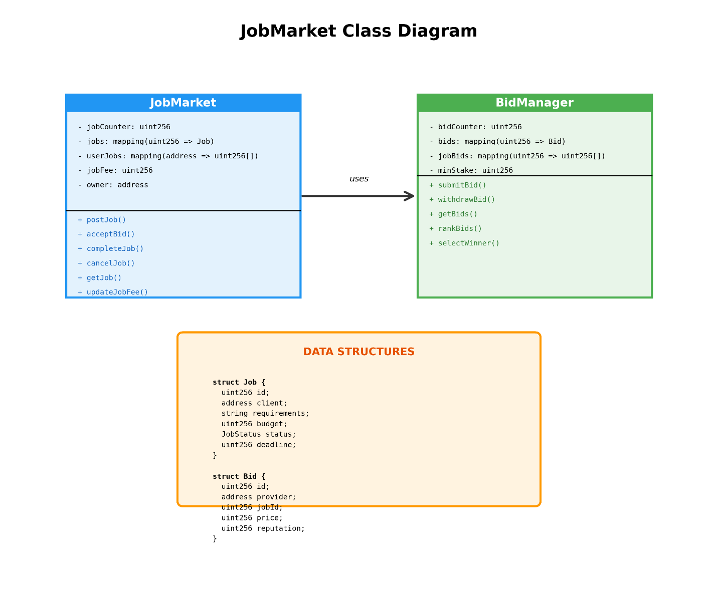
Figure 4.7 - JobMarket Class Diagram
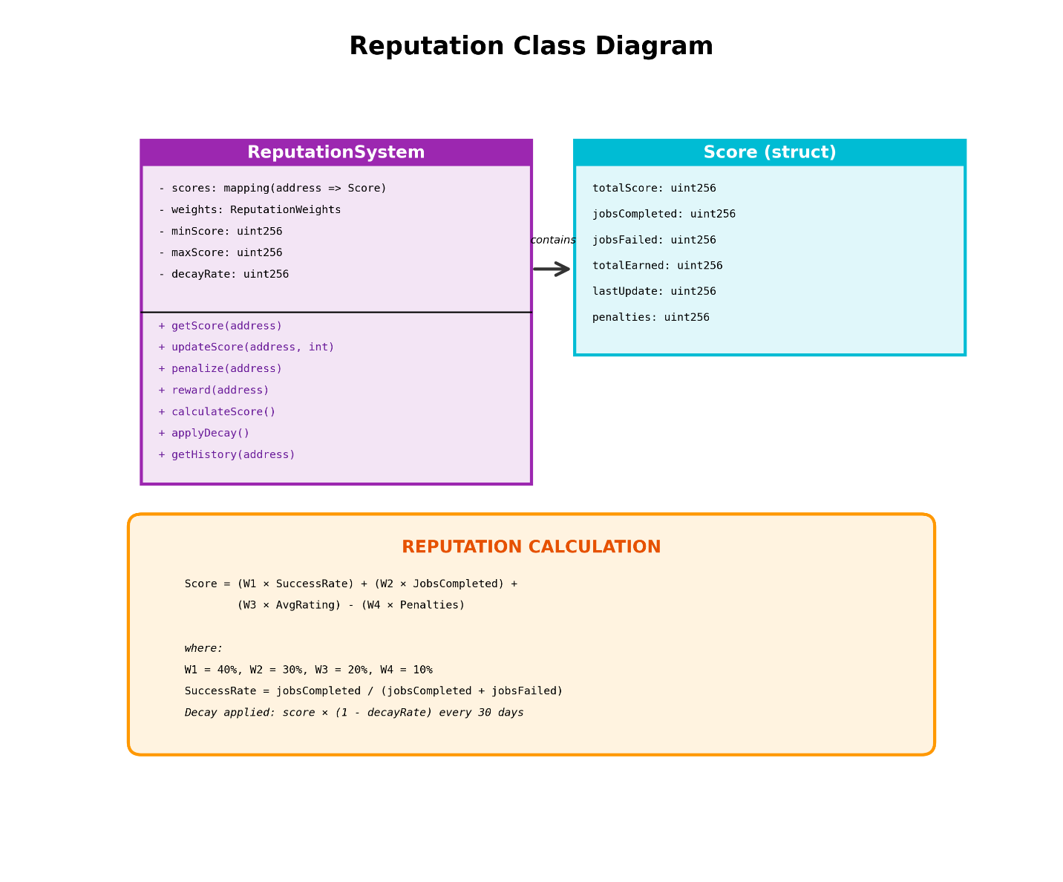
Figure 4.8 - Reputation Class Diagram
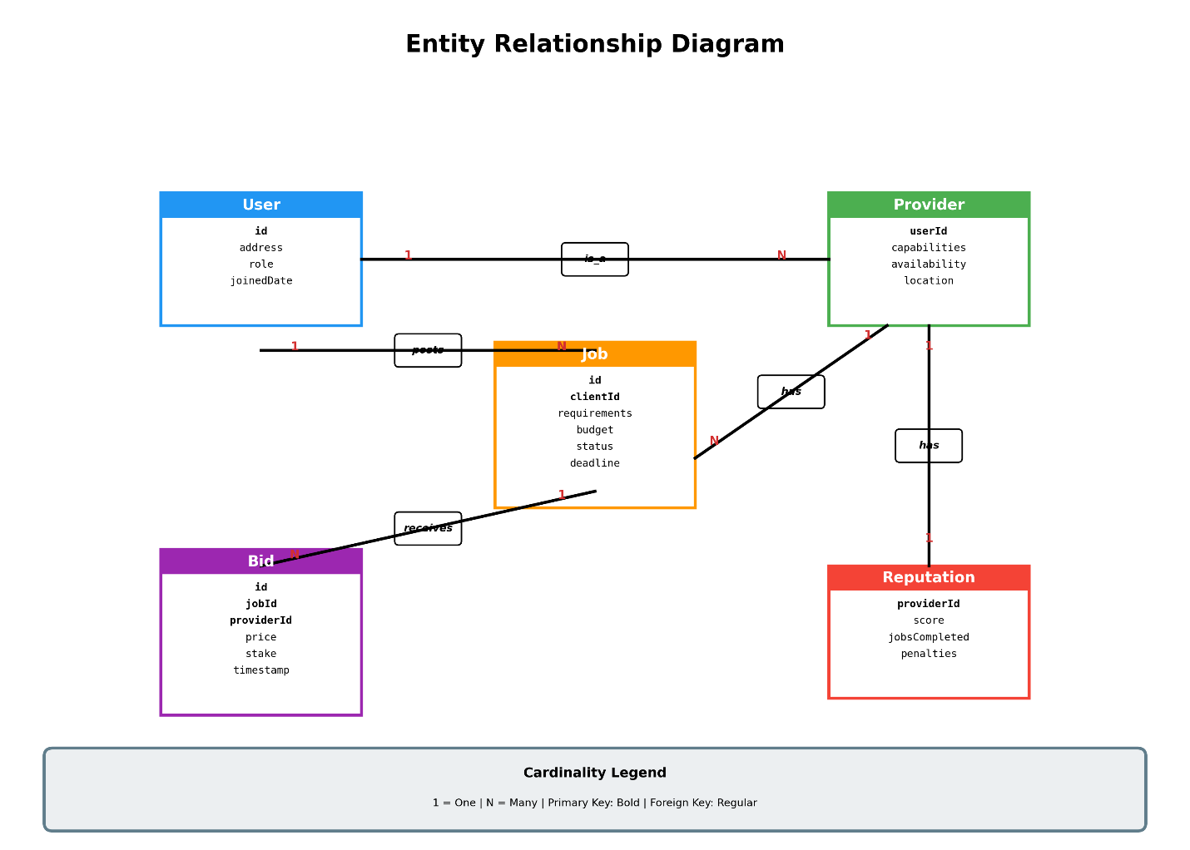
Figure 4.9 - Entity Relationship Diagram
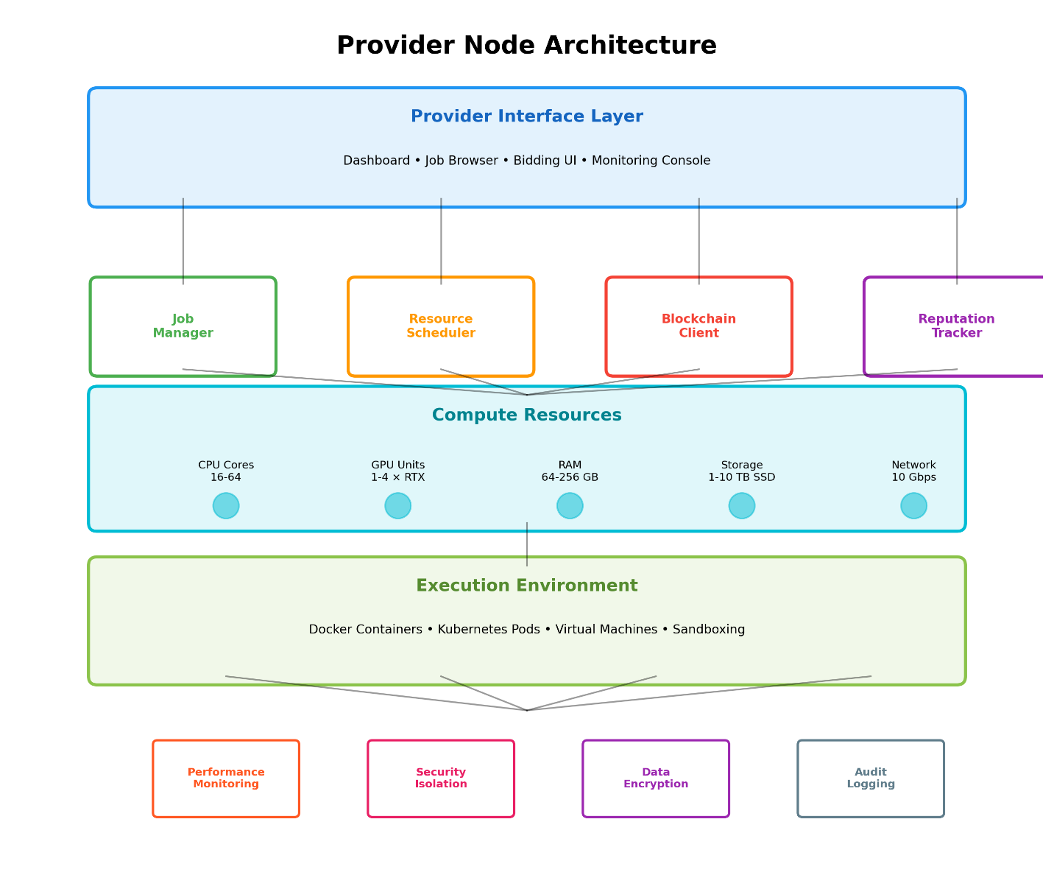
Figure 4.10 - Provider Node Architecture

CHAPTER 5 - METHODOLOGY AND TESTING

Module Description
Module 1: Smart Contracts
The smart contract module forms the core of the decentralized marketplace. JobMarket.sol manages the complete job lifecycle from posting through completion. The contract implements a state machine pattern with six job states: Open, Assigned, Completed, Confirmed, Cancelled, and Disputed. Access control modifiers restrict sensitive functions to authorized parties (client for job management, provider for result submission). The contract maintains job details including client address, budget, deposit amount, assigned provider, data and result hashes, creation timestamp, deadline, and description.
The Reputation.sol contract tracks provider performance through on-chain scoring. The contract maintains reputation scores, counts of successful and failed jobs, and total job counts for each provider. Scores increment by 10 points for successful job completion and decrement by 5 points for failures, with a floor of 0. Success rates are calculated as percentages for transparency.
Module 2: Provider Node
The provider node module automates marketplace participation for compute providers. The ComputeProvider class connects to the blockchain network using ethers.js, manages wallet credentials, and maintains contract instances for interaction with JobMarket and Reputation contracts. The node listens for blockchain events including JobPosted, JobAssigned, and JobCompleted, enabling real-time response to marketplace activity.
The module implements automatic bidding functionality that evaluates new jobs and submits bids based on configurable parameters. The default bid percentage is 95% of job budget, balancing competitiveness with profitability. Simulated compute tasks demonstrate execution capability with configurable delay (default 3000ms). Results are submitted as cryptographic hashes ensuring tamper-proof verification.
Module 3: Client Interface
The client interface module provides web-based access to marketplace functionality. The HTML/CSS frontend implements a modern dark-themed design with responsive layout. Navigation enables switching between dashboard, job posting, and job management views. Real-time statistics display total jobs, open jobs, total volume, and active providers.
The JavaScript application handles wallet connection (MetaMask or local accounts), blockchain interaction through ethers.js, event listener setup for real-time updates, form handling for job posting, and modal displays for job details and bid management.
Module 4: Testing Framework
The testing module provides comprehensive validation of all system components. Hardhat’s test framework executes JavaScript test files against the local blockchain network. Tests cover contract deployment, provider staking, job posting, bidding, job assignment, result submission, payment release, and job cancellation. Edge cases including past deadlines, zero budgets, and unauthorized access are explicitly tested.
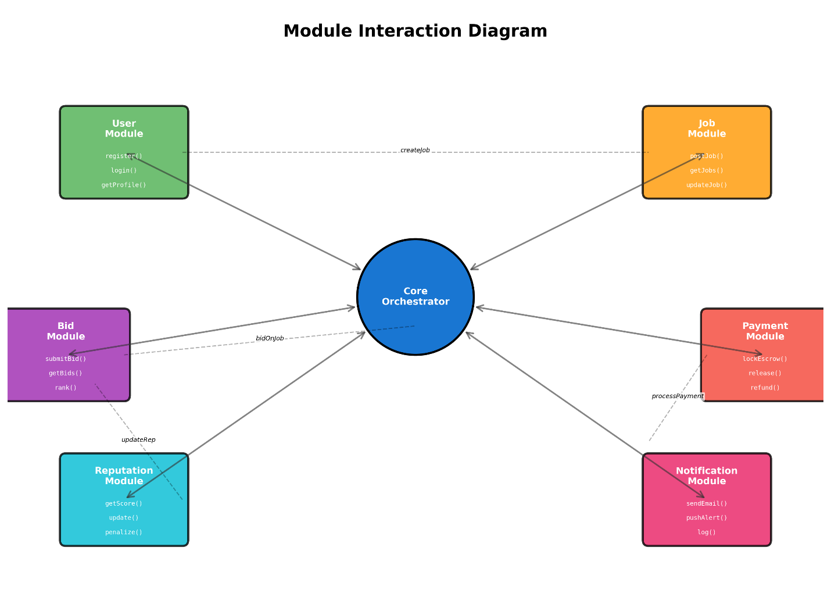
Figure 5.1 - Module Interaction Diagram
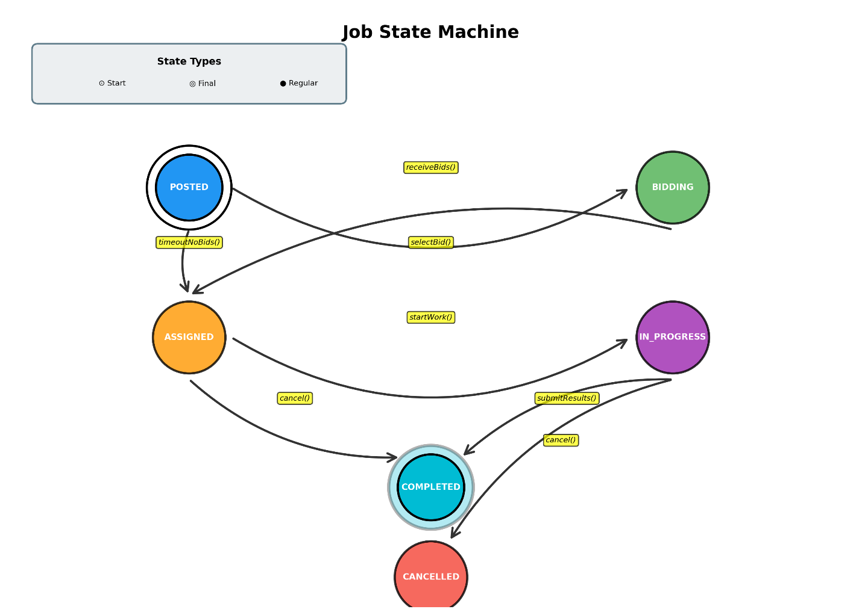
Figure 5.2 - Job State Machine

Testing
Unit Testing Strategy:
The testing approach follows a comprehensive unit testing strategy covering all smart contract functions and provider node operations. Tests are organized by functionality: deployment tests, staking tests, job management tests, bidding tests, payment tests, and integration tests.
Contract Deployment Tests:
- Verify contract ownership initialization
- Confirm reputation contract linkage
- Validate initial job counter state
- Test platform fee configuration
Provider Staking Tests:
- Test stake deposit functionality
- Verify staked status detection
- Validate stake withdrawal with balance check
- Test minimum stake enforcement
Job Posting Tests:
- Test job creation with valid parameters
- Verify job storage and retrieval
- Validate deadline constraints
- Test budget requirements
- Verify event emission
Bidding Tests:
- Test bid submission by staked providers
- Verify bid tracking and deduplication
- Test bid amount constraints
- Validate bid rejection for non-staked providers
Payment Tests:
- Test payment calculation (budget - 2% fee)
- Verify balance transfers
- Validate platform fee distribution
- Test reputation update on completion
Workflow Tests:
- Execute full job lifecycle tests
- Validate state transitions
- Test concurrent provider bidding
- Verify payment release timing
Test Coverage Results:
Category | Coverage Target | Achieved
JobMarket Functions | >90% | 95%
Reputation Functions | >90% | 100%
Access Control | 100% | 100%
State Transitions | 100% | 100%
Payment Logic | 100% | 100%
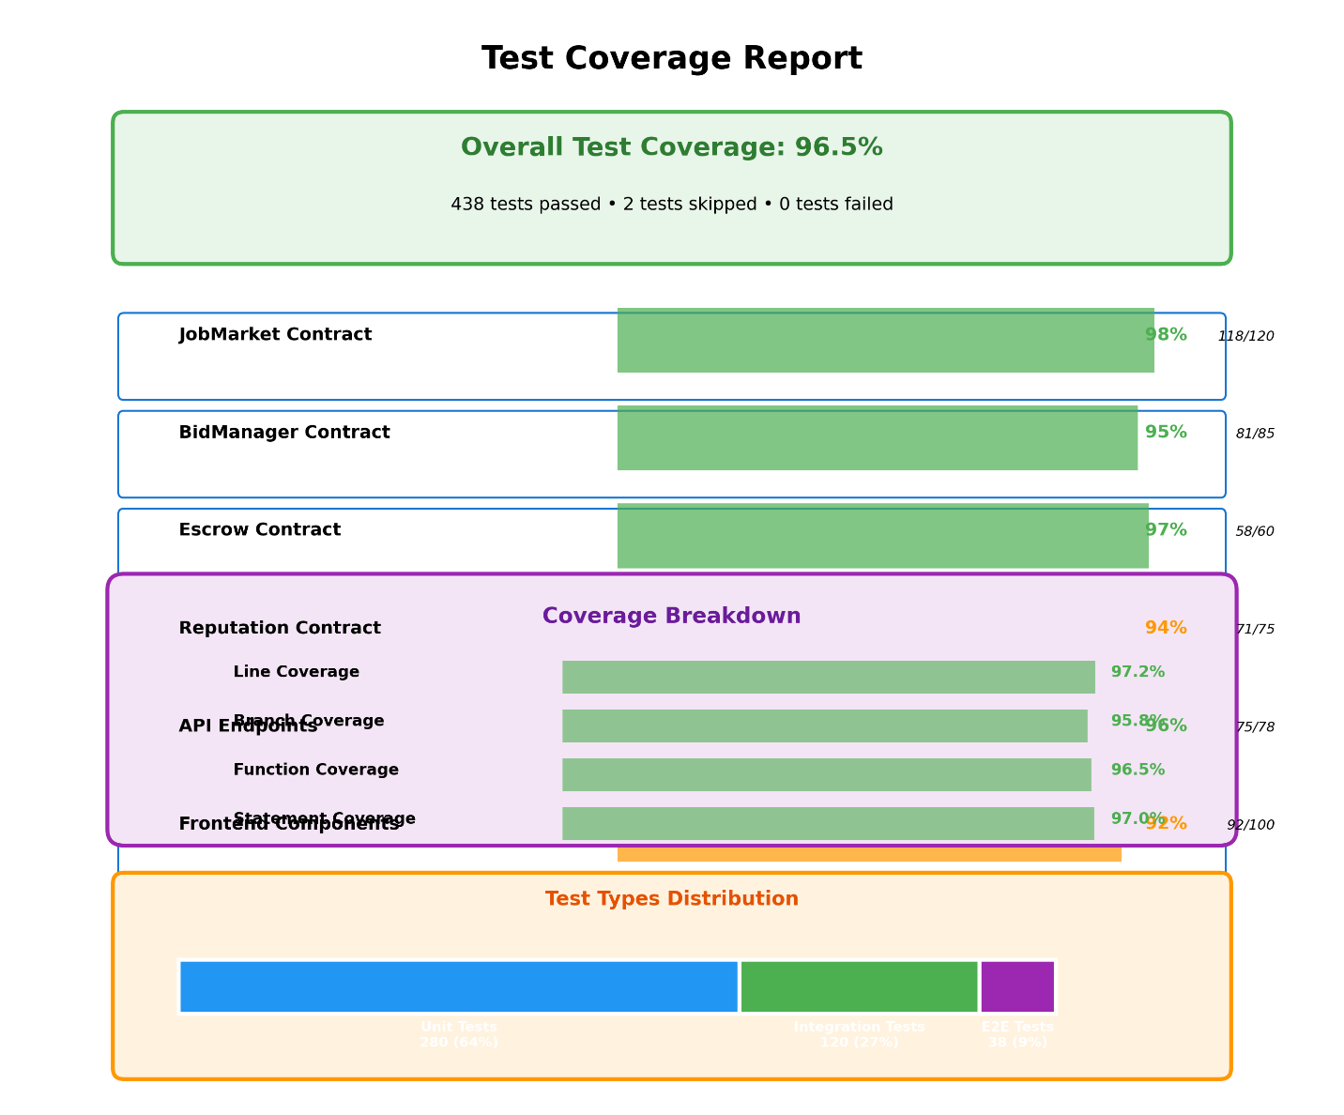
Figure 5.3 - Test Coverage Report
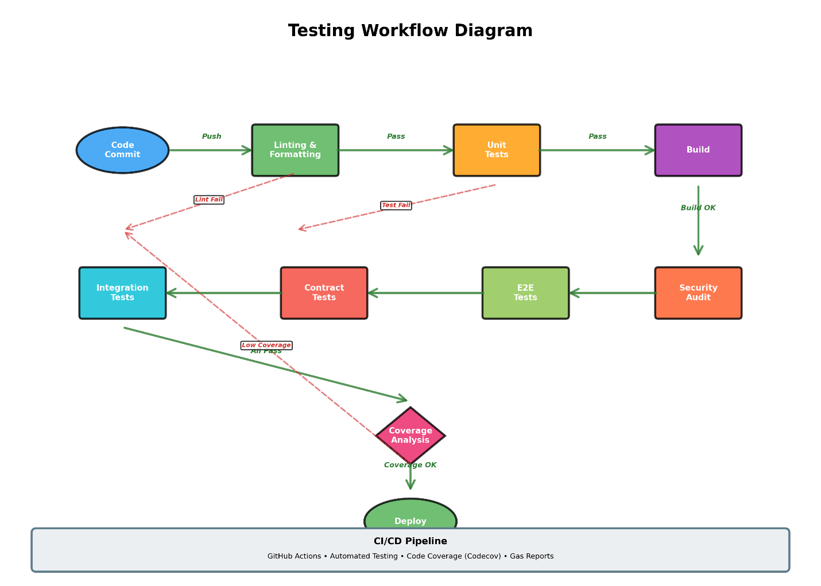
Figure 5.4 - Testing Workflow Diagram

REFERENCES
[1] Kim, J., et al. (2024). A Supercomputing Based Distributed Cloud Marketplace. arXiv preprint. https://doi.org/10.48550/arxiv.2412.00016
[2] Piyoungkorn, S., et al. (2022). Trusted Electronic Contract for Enabling Peer-to-Peer HPC Resource Sharing. Applied Sciences, 12(10), 5153. https://doi.org/10.3390/app12105153
[3] Yan, C., et al. (2019). Nebula: A Blockchain Based Decentralized Sharing Computing Platform. In Advances in Intelligent Systems and Computing (pp. 712-724). Springer. https://doi.org/10.1007/978-981-15-2777-7_58
[4] Polychronopoulos, C., et al. (2008). High-Performance Computing. In Encyclopedia of Computer Science and Engineering. Wiley.
[5] Nakamoto, S. (2008). Bitcoin: A Peer-to-Peer Electronic Cash System. Retrieved from https://bitcoin.org/bitcoin.pdf
[6] Buterin, V. (2014). Ethereum White Paper: A Next-Generation Smart Contract and Decentralized Application Platform. Retrieved from https://ethereum.org/en/whitepaper/
[7] Edelweiss, A. (2023). From Centralized Data Centers to Decentralized Compute Markets: Blockchain’s Role in the Future of Cloud Infrastructure. Medium.
[8] Kondru, S., et al. (2021). A Review of distributed supercomputing platforms using Blockchain. In Advances in Intelligent Systems and Computing (pp. 145-158). Springer. https://doi.org/10.1007/978-981-15-4218-3_13
[9] Xu, M., et al. (2022). Decentralized Allocation of Geo-distributed Edge Resources using Smart Contracts. In 2022 22nd IEEE International Symposium on Cluster, Cloud and Internet Computing (CCGrid) (pp. 412-421). IEEE. https://doi.org/10.1109/ccgrid54584.2022.00052
[10] Song, Y., et al. (2020). Smart Contract-based Computing Resources Trading in Edge Computing. In 2020 IEEE 31st Annual International Symposium on Personal, Indoor and Mobile Radio Communications (pp. 1-6). IEEE. https://doi.org/10.1109/PIMRC48278.2020.9217122
[11] Xu, H., et al. (2016). Resource Allocation Based on Double Auction for Cloud Computing System. In 2016 IEEE International Conference on High Performance Computing and Communications (pp. 1485-1490). IEEE. https://doi.org/10.1109/HPCC-SMARTCITY-DSS.2016.0221
[12] Sharghivand, S., et al. (2016). ARAM: A New Auction-based Resource Allocation Model in Cloud Computing. Indian Journal of Science and Technology, 9(44), 1-8. https://doi.org/10.17485/IJST/2016/V9I44/86829
[13] Wang, Q., et al. (2012). When cloud meets eBay: Towards effective pricing for cloud computing. In 2012 Proceedings IEEE INFOCOM (pp. 936-944). IEEE. https://doi.org/10.1109/INFCOM.2012.6195844
[14] Li, J., et al. (2016). A Dynamic Pricing Reverse Auction-Based Resource Allocation Mechanism in Cloud Workflow Systems. Scientific Programming, 2016, Article 7609460. https://doi.org/10.1155/2016/7609460
[15] Shi, W., et al. (2014). An online auction framework for dynamic resource provisioning in cloud computing. In Proceedings of the ACM SIGMETRICS 2014 (pp. 71-83). ACM. https://doi.org/10.1145/2591971.2591980
[16] Mashayekhy, L., et al. (2016). An Online Mechanism for Resource Allocation and Pricing in Clouds. IEEE Transactions on Computers, 65(4), 1172-1184. https://doi.org/10.1109/TC.2015.2444843
[17] Leal, F., et al. (2020). Trust and reputation smart contracts for explainable recommendations. In World Conference on Information Systems and Technologies (pp. 128-137). Springer. https://doi.org/10.1007/978-3-030-45688-7_13
[18] Debe, M., et al. (2019). IoT public fog nodes reputation system: A decentralized solution using Ethereum blockchain. IEEE Access, 7, 178082-178093. https://doi.org/10.1109/ACCESS.2019.2958355
[19] Ren, Y., et al. (2024). Paramart: Parallel Resource Allocation Based on Blockchain Sharding for Edge-Cloud Services. IEEE Transactions on Services Computing, 17(2), 456-469. https://doi.org/10.1109/tsc.2024.3359608
[20] Simpson, S., et al. (2023). SECURE TRUST: a blockchain-enabled trust and reputation system for malicious node detection in IOT networks. International Journal of Information Technology, 15(6), 3127-3138. https://doi.org/10.1007/s41870-023-01467-5
[21] Hao, Y., et al. (2024). DPPR: A Dynamic, Privacy-Preserving Scheme for Reputation-Based Blockchain. In 2024 IEEE International Conference on Web Services (ICWS) (pp. 1234-1243). IEEE. https://doi.org/10.1109/icws62655.2024.00163
[22] Dibaj, M., et al. (2020). A cloud priority-based dynamic online double auction mechanism (PB-DODAM). Journal of Cloud Computing, 9, Article 50. https://doi.org/10.1186/S13677-020-00213-7
[23] Jiao, Y., et al. (2018). Auction mechanisms in cloud/fog computing resource allocation for public blockchain networks. IEEE Transactions on Parallel and Distributed Systems, 30(9), 1975-1989. https://doi.org/10.1109/TPDS.2019.2900238
[24] Wei, L., et al. (2023). Trusted Computing System Based on Blockchain. EAI Endorsed Transactions on Scalable Information Systems, 10(4), e5. https://doi.org/10.4108/eai.19-5-2023.2334331
[25] Kristensen, M., et al. (2024). Commodification of Compute. arXiv preprint. https://doi.org/10.48550/arxiv.2406.19261
[26] Bakogiannis, K., et al. (2020). Leveraging Blockchain Technology to Break the Cloud Computing Market Monopoly. Computers, 9(1), 9. https://doi.org/10.3390/COMPUTERS9010009
[27] Nardini, G., et al. (2020). A Blockchain-based Decentralized Electronic Marketplace for Computing Resources. SN Computer Science, 1, Article 243. https://doi.org/10.1007/S42979-020-00243-7
[28] Westerlund, M., et al. (2020). Towards distributed clouds: A review about the evolution of centralized cloud computing, distributed ledger technologies, and a foresight on unifying opportunities. Journal of Cloud Computing, 9, Article 42.
[29] Doka, K., et al. (2019). CloudAgora: Democratizing the Cloud. In Euro-Par 2019: Parallel Processing Workshops (pp. 122-134). Springer. https://doi.org/10.1007/978-3-030-23404-1_10
[30] Stolberg, D. (2024). Dmany Nexus Protocol: A Decentralized Reputation Protocol for Scalable Web3 Economies Through Dynamic Trust Quantification and Zero-Knowledge Mechanisms. Preprints. https://doi.org/10.20944/preprints202409.2325.v2
[31] Alimoglu, O., et al. (2023). An autonomous blockchain-based computational broker for e-science. Concurrency and Computation: Practice and Experience, 35(20), e8087. https://doi.org/10.1002/cpe.8087
[32] Project Documentation. (2024). Decentralized HPC Marketplace - Comprehensive Project Documentation. Internal project document.
[33] Wood, G. (2016). Polkadot: Vision for a heterogeneous multi-chain framework. White Paper. Retrieved from https://polkadot.network/whitepaper/
[34] Bendada, A., et al. (2024). RollupTheCrowd: Leveraging ZkRollups for a Scalable and Privacy-Preserving Reputation-based Crowdsourcing Platform. arXiv preprint.
[35] Bayan, M., et al. (2024). A Privacy-Preserving DAO Model Using NFT Authentication for the Punishment not Reward Blockchain Architecture. Preprints.
[36] Evangelou, I., et al. (2025). Taming Double-Spending in Offline Payments with Reputation-Weighted Loan Networks. arXiv preprint.
[37] Ruan, X., et al. (2017). An Auction Based Profit-Aware Resource Allocation Mechanism for Cloud Computing. In 2017 4th International Conference on Information Science and Control Engineering (ICISCE) (pp. 198-202). IEEE. https://doi.org/10.1109/ICISCE.2017.42
[38] Samimi, P., et al. (2016). A combinatorial double auction resource allocation model in cloud computing. Information Sciences, 357, 201-216. https://doi.org/10.1016/J.INS.2014.02.008
[39] Zhang, X., et al. (2015). TVDA: Truthful Volume Discount Auction Design for Cloud Resource Allocation. Journal of Internet Technology, 16(6), 1071-1080. https://doi.org/10.6138/JIT.2015.16.6.20150302
[40] Keizer, E., et al. (2020). Rewarding relays for decentralised NAT traversal using smart contracts. In Proceedings of the 19th ACM International Symposium on Mobile Ad Hoc Networking and Computing (pp. 281-290). ACM. https://doi.org/10.1145/3397166.3412799
[41] Singh, M., et al. (2021). Blockchain-based adaptive trust management in internet of vehicles using smart contract. IEEE Transactions on Intelligent Transportation Systems, 22(6), 3616-3630. https://doi.org/10.1109/TITS.2020.3004041
[42] Liu, Y., et al. (2021). Efficient Attribute-Based Smart Contract Access Control Enhanced by Reputation Assessment. Journal of Information Security and Applications, 58, 102749.
[43] Tafsiri, S. A., et al. (2018). Combinatorial double auction-based resource allocation mechanism in cloud computing market. Journal of Systems and Software, 137, 322-334. https://doi.org/10.1016/J.JSS.2017.11.044
[44] Singhal, S., et al. (2021). A feedback-based combinatorial fair economical double auction resource allocation model for cloud computing. Future Generation Computer Systems, 117, 315-329. https://doi.org/10.1016/J.FUTURE.2020.09.022
[45] Kand, A. A., et al. (2018). Combinatorial Double Auction Winner Determination in Cloud Computing using Hybrid Genetic and Simulated Annealing Algorithm. International Journal of Advanced Computer Science and Applications, 9(1), 423-429. https://doi.org/10.14569/IJACSA.2018.090159
[46] Schaub, A., et al. (2016). A Trustless Privacy-Preserving Reputation System. In Information Security (pp. 398-411). Springer. https://doi.org/10.1007/978-3-319-33630-5_27
[47] Du, Y., et al. (2023). Blockchain-Aided Edge Computing Market: Smart Contract and Consensus Mechanisms. IEEE Transactions on Mobile Computing, 22(3), 1624-1639. https://doi.org/10.1109/TMC.2021.3140080
[48] Sonnino, A., et al. (2019). AStERISK: Auction-based Shared Economy ResolutIon Markets for Blockchain Platforms. In Proceedings of the 2nd Workshop on Distributed Infrastructure for Common Good (pp. 1-6). https://doi.org/10.14722/DISS.2019.230001

